Capstone Proposal Final Report

Solar Luggage Cart

**EECE.3991 – Engineering Capstone Proposal**

**April 28, 2023**

**Team Members:  
Thomas Cecelya  
Matthew DeSantis  
Casey Merola  
Keegan Smith  
Jameson Tucker**

**Sponsor and Mentor:**  
**Professor Samson Mil’shtein**  
**Jeffrey Snell**

**Executive Summary**

**Solar-Powered Luggage Cart**

Mentor and Client: Dr. Samson Mil’shtein and Jeffrey Snell

Team Members: Thomas Cecelya (EE), Matthew DeSantis (EE), Casey Merola (EE), Keegan Smith (EE), Jameson Tucker (EE)

The transportation industry heavily contributes to global climate change, and cleaning up this industry would significantly reduce carbon emissions. With airports utilizing many ground vehicles to operate quickly and efficiently, a cleaner vehicle that can remove a large part of the power grid carbon emissions is desirable. Most electric vehicles utilize the electric grid for recharging, which is powered by carbon emitting fossil fuels.

This project proposes a solution to inefficient gasoline powered luggage carts used in airports by creating a battery powered luggage cart that charges through solar energy and operates using in-wheel hub motors, removing grid dependency. The project requires multiple electric motors, batteries, and solar panels, in addition to the mechanical components required to build the cart. The project is expected to cost less than $20,000, which is supplied by the Advanced Electronic Technology Center at the University of Massachusetts Lowell. The project is expected to take place until December 2023 without work being done in the summer.

This project will offer insight into the ability of solar energy to run a vehicle capable of towing large weights without the use of any other type of energy. If successful, this project will demonstrate that it is possible for a self-sustaining solar electric vehicle to tow enough weight to fill an airplane with luggage, pushing the commercial aviation industry to become more environmentally friendly.

This project is currently in the design stage, moving into the preliminary building and testing phase. The team has produced preliminary mechanical designs, electrical block diagrams, circuitry schematics and code flowcharts. Batteries and an existing mechanical frame have also been acquired for the project. The problem has been well defined, and the team has decided on a solution.

Sketch of the system with one cart. Not to scale

# **Introduction**

With the increased awareness of global climate change, there is a push to clean our planet’s energy sources. The result is an increase in research of electric vehicle technology as a more environmentally friendly alternative to the standard internal combustion engine [1]. While there is an improvement in efficiency for electric vehicles, the electric grid that is used to charge these vehicles still relies on carbon-based fuel to create electricity. This carbon emission is significant and contributes the largest portion of the environmental impact from electric vehicles [1]. Because of this, there is an incentive to research the use of cleaner energy than the grid can provide, with solar energy as a safe and appropriate alternative.

This project is being undertaken with the guidance of Professor Emeritus Samson Mil’shtein and has the purpose of creating a solar-powered, off-grid electric vehicle intended for use at an airport that can tow luggage between an airport terminal and an airplane. This research contribution would prove that a cleaner aviation industry is possible, opening the door to other high-powered solar applications.

This report gives a description of the project’s structure, beginning with a description of the client and their involvement with the university and their field. The report also includes a description of what is to be designed and delivered and states the main problem and main objective of the project. Research into existing electric vehicle designs, vehicle dynamics, motors, batteries, photovoltaic cells, and circuitry is performed, to ensure that the project can be understood. Requirements are written to establish what the final system will be able to do, and possible solutions are compared and selected. Finally, the report includes preliminary design for the project, including an electrical and mechanical block diagram, a proposed electrical schematic, and a preliminary bill of materials.

# **Client Background**

The Advanced Electronic Technology Center (AETC) works with industry partners to develop students in the areas of engineering [2]. It was founded in 1990 and its stated mission is to give “an opportunity to all ages of school students to explore scientific topics and to study engineering [2].” The AETC sponsors research in fields ranging from Quantum Electronics to Biomedical Engineering and, most importantly to this project, Solar Cells. The projects that the AETC focuses on are those that can develop “reliable manufacturing for giga-scale miniaturization technology [2].” The AETC also hosts the Young Engineers Academy, which seeks to encourage middle and high school students to participate in engineering courses at UML. The AETC has been led by Dr. Samson Mil’shtein since its inception in 1990.

According to his faculty page on the University of Massachusetts Lowell (UML) website, Dr. Samson Mil’shtein received his BS and MS in Solid State Physics from the State University of Odessa in the then-U.S.S.R. in 1961 and 1963, respectively [3]. He then went on to obtain two Ph.D.’s: one in Solid State Physics in 1970 from the Institute of Solid-State Physics and a second in Applied Physics in 1975 from the Hebrew University of Jerusalem. He has been awarded 37 patents for applications ranging from various solar cell applications to Bipolar Junction Transistor (BJT) and Metal Oxide Semiconductor Field Effect Transistor (MOSFET) applications. He has authored or co-authored over 150 papers in the fields of BJT and MOSFET technology, among others. He served as an active UML professor from 1987 until 2020. He also held the position of Assistant Dean of Engineering for Research for 1 year before becoming the director of the newly created Advanced Electronic Technology Center (AETC) in 1990.

# **Project Concept**

## ***Initial Description***

This project proposes a possible solution to the grid reliance that other electric vehicles require by utilizing solar energy to power the system. The project proposed by Professor Mil’shtein will explore the possibility of creating an electric luggage carrier that can be charged through solar energy and is capable of towing luggage for a full commercial airplane. The system is expected to be able to operate indefinitely from normal use through solar and battery power, which would result in a luggage carrier that is completely isolated from the grid.

## ***Expected Deliverables***

The group is expected to deliver a luggage cart prototype that serves as a proof of concept demonstrating that a solar-powered electric vehicle can be used for luggage towing. The group will also deliver a research paper offering important insight into the relatively new field of hub-motor electric vehicles.

## ***Benefits***

If successful, this project is designed to produce one of the only off-grid vehicles that can perform a task as needed without ever running out of power. This results in no carbon emissions in the power supply system outside of the manufacturing process, and the finished product will have a positive impact on an industry known for having poor sustainability.

# **Research**

## ***Existing Designs***

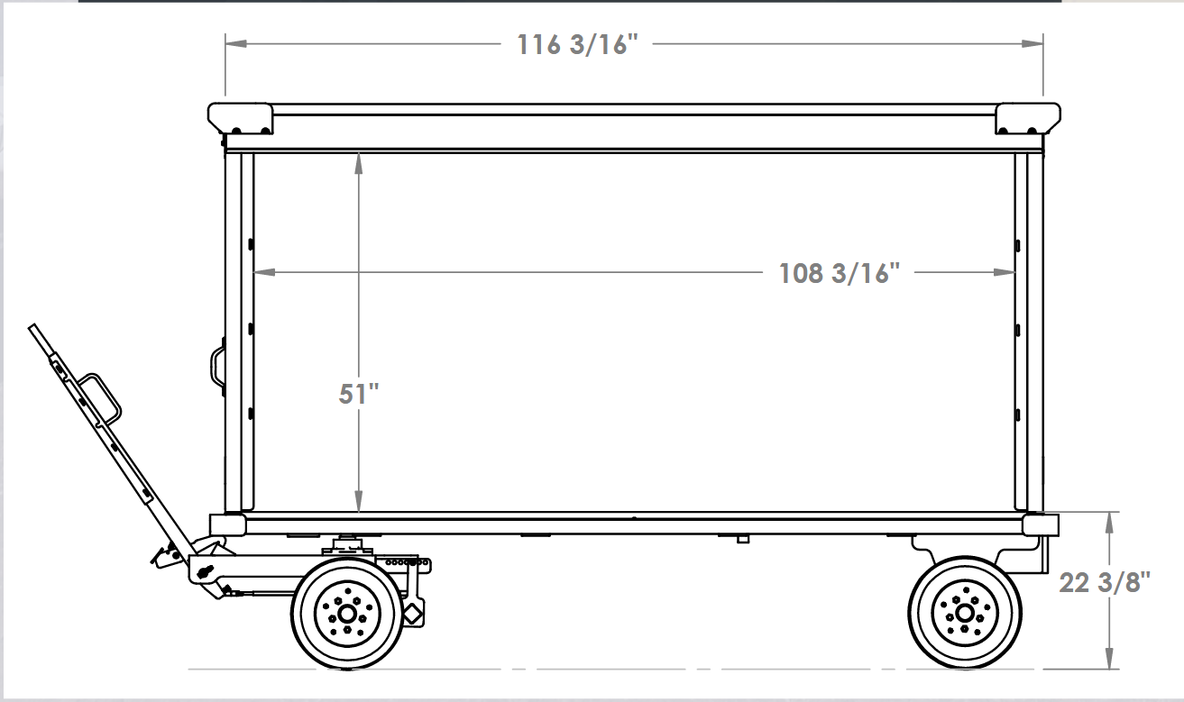

Figure 1. Typical luggage cart dimensions [4]

The technical specifications for electric towing vehicles used in the industry come from a data sheet produced by Alkè for their line of products [5]. Current production-model battery-powered towing vehicles operate using anywhere from 24 V to 48 V batteries which provide 14.4 kWh for two 24 V lead-acid batteries, 13.2 kWh for two 24 V gel-type batteries, and topping out at 20 kWh for a single 48 V lithium-ion battery [5] [6]. Further research also provided two more models of electric towing vehicles listed on Alibaba.com, both of which used either 24 V or 48 V batteries, and one had a listed towing capacity of 9000 N [7] [8]. The range provided by the lead-acid or Gel-type batteries is anywhere from 54 km to 119 km. Alkè uses 96 V AC brushless induction motors which provide a maximum motor power of 14 kW. Alkè’s available models have anywhere from 2800 N to 6500 N of traction power and generate around 113 Nm of torque. This allows them to tow up to 2000 kg on a paved surface. We can use these ranges to determine if we are meeting or exceeding the required forces and performance to accomplish our goals.

## ***Mechanical Calculations***

Table 1. Index of mechanical parameters for tractive force, torque, and power calculations

|  |  |  |
| --- | --- | --- |
| **Variables** | | |
| **Symbol** | **Description** | **Units** |
| *a* | Desired acceleration of system | $$\frac{m }{s^{2}}$$ |
| *m* | System mass | $$kg$$ |
| *g* | Acceleration due to gravity | $$\frac{m }{s^{2}}$$ |
| $$n_{d}$$ | Number of drive wheels | *n/a* |
| $$n_{c}$$ | Number of wheels contacting ground | *n/a* |
| $$μ$$ | $(μ_{f} + μ_{r})$ Coefficient of friction and rolling resistance | *n/a* |
| $$r_{wheel}$$ | Radius of wheels | $$m$$ |
| $$v_{max}$$ | Max velocity | $$\frac{m}{s}$$ |
| $$F_{t}$$ | Tractive Force | $$N$$ |
| $$τ$$ | Torque | $$N⋅m$$ |
| $$P$$ | Power | $$W$$ |
| $$J$$ | Moment of Inertia | $$kg⋅m^{2}$$ |
| $$T$$ | Acceleratory Torque | $$N⋅m$$ |

$J=\frac{\left(m⋅r^{2}\right)}{2g}$ (1)

$T=\frac{\left(J⋅π⋅RPM\right)}{360t}$ (2)

$F_{t}=n_{d}μ\frac{mg}{n_{c}}cosθ+mgsinθ$ (3)

$τ_{max}=\frac{F_{t}∙r_{wheel}}{n_{d}}$ (4)

$P_{max}=\frac{τ∙v_{max}}{r_{wheel}}$ (5)

Equation (1) gives the force required to accelerate a load based on the moment of inertia of the wheel. Breaking down the equation, m is the mass acting on the wheel, r is the radius of the wheel, and g is acceleration due to gravity. This moment of inertia can then be used in the equation (2) to determine the torque (our driving force) required to accelerate to a desired velocity. Equation (2) shows J as the moment of inertia calculated with equation (1), RPM is the desired rotations per minute, and t is the time spent accelerating to the desired RPM [9].

Equations (3), (4), and (5) are the main equations that will be used for the system’s calculations. Equation (3) describes the tractive force of the system. Tractive force is the total amount of force the drive wheels can apply to the ground [10], meaning it is the max force each drive wheel can supply before the wheels “slip” or lose traction. This number will help decipher the max ratings for the system. To derive the tractional force equation, the normal force is “split” up between the wheels that have contact with the ground. Then, the normal force is multiplied by the coefficient of friction, since friction increases the force needed. For one drive wheel the equation is complete, but for multiple drive wheels, the max force is increased, and the result is multiplied by the number of drive wheels. The complete equation is the number of drive wheels multiplied by the coefficient of friction and the normal force divided by the number of wheels contacting the ground and multiplied by the cosine of the incline being traveled on. The cosine yields the force component of moving up the incline. After that, the force due to gravity pulling the system down, hence sine of the incline, can be added to produce tractive force.

Equation (4) is the torque calculation and will tell the max radial force (torque) each drive wheel can supply. Torque has units $N⋅m$ so, multiplying our tractive force, with the units of Newtons, by the radius of the wheel, in meters, will give the tractive torque of the system. Then, the max torque each wheel can supply is found dividing by the total number of drive wheels. The torque calculation at each wheel is important for selecting motors since electric motors can only produce a set amount of it and if enough torque cannot be generated, a single state or a multi-stage transmission may be needed to compensate.

Equation (5) is also important for motor selection as it determines the power required to reach a certain velocity, or speed, with a specific torque and wheel radius. The unit of power is Watts, but Watts can also be written as $\frac{N⋅m}{s}$. Using this relationship, torque (N-m) can be multiplied by a desired velocity (m/s), then divided by the radius of the wheel (m), resulting in $\frac{N⋅m}{s}$. If the system needs to be faster, more power or a smaller wheel radius could be a solution. However, a transmission could allow a lower-powered motor to produce more torque, but transmissions typically absorb 10 to 20% of the power going into them [11]. Direct drives, such as the hub motors being investigated for this system, would not have this power loss.

## ***Motors***

A large component in the design of an electric vehicle is the motor system, which must be appropriately selected to fit the needs of the system. The motors most used for electric vehicles are alternating current (AC) induction motors, and direct current (DC) motors, both of which have their advantages and disadvantages. AC motors work on the principle of producing torque through a rotating magnetic field that pulls a metal rotor along with it [12], and DC motors work by passing DC current through a loop of wire in the presence of a magnetic field [12]. AC motors can produce incredibly high amounts of power but require AC voltage and usually require 3 phases [12]. This is appropriate for high-speed electric cars, which require the high torque that an AC motor can produce, such as the Tesla model 3 [13] and the BMW fifth-generation electric vehicles [14]. However, if power this high is not needed, DC motors are easier to work with and are usually more efficient.

DC motors can work under lower voltage, but since power depends on the supplied voltage and the current, there will be less power available compared to AC motors. It is unfeasible to produce a battery system higher than 100V for this application, so DC motors are a clear frontrunner to produce a working result. This is confirmed through other small electric vehicle designs, like utility vehicles and golf carts from Club Car and Yamaha, which are available with DC or AC motors [15] [16]. Even these utility vehicles may require AC power, however, as the highest power output vehicle from Club Car is only available with an AC motor [17].

DC motors can be split into two categories, brushed and brushless, which are different methods of delivering power to the motor. Because the magnetic field in a DC motor does not change, the rotor will experience a magnetic force in the same direction, and as it rotates, it would produce a net torque of zero [12]. Brushes solve this problem by attaching physical, conductive material to the rotor, which changes the polarity of the rotor’s voltage throughout a cycle of rotation, producing a net positive torque and allowing the motor to rotate [12]. The brushes introduce physical and electrical losses, and will deteriorate over time [12], causing them to not be as usable for high power applications. When high power is required, brushless DC (BLDC) motors are used, which utilize electronic logic to change the motor’s polarity and generate positive torque throughout the rotor’s cycle [12]. This type of motor solves all the efficiency problems related to the brushes, as there is no voltage drop or friction from the brushes [18], and as a byproduct they are smaller and more powerful [18].

Different types of BLDC motors exist and have different applications. The magnetic field can be produced with a current passing through a winding, or with a permanent magnet. With the magnetic field being produced with a winding, current must be supplied to the motor, as the magnetic field needs to be produced with electric power [12]. This method of power is useable when power is not the largest consideration for a system, but an electric vehicle requires high efficiency to be viable, since it is battery powered and has a limited power output. When a permanent magnet is used to produce the motor’s field, the magnetic field is generally weaker [12], but the power comes as a property of the permanent magnet [19], and not from the battery.

Each type of motor that could be used has a configuration that is suited the best for its application. Since an AC motor has the highest power output, but is heavier than a DC motor, it is best suited as a mid-drive motor powering all the drive wheels simultaneously. This method usually requires a complex gearing system, common on most current electric vehicles [20], since all the drive wheels are not necessarily moving at the same speed. DC motors can be used to drive multiple wheels, but since they tend to have less of a power output, a more efficient solution is to drive the motors through each driving wheel separately [19] [20], which removes the complex drivetrain and makes the vehicle significantly lighter and more efficient [21] [22] [19]. This configuration is called a hub motor because each wheel hub that is powered contains the motor inside it [19]. Hub motors are being produced by Elaphe [21], Protean [22], and Orbis [23], which offer commercially available solutions to the efficiency loss noted with other types of electric vehicles and are finding a footing in the market for electric vehicles.

## ***Batteries***

Table 2. Index of battery parameters [24]

|  |  |  |
| --- | --- | --- |
| Important Battery Parameters | | |
| Parameter | Units | Description |
| Nominal Voltage | Volts [V] | Voltage rating of the battery |
| Rated Capacity | Amperage per hour [Ah] | How many amps can be provided for one hour |
| Maximum Charge Current | Amps [A] | How much current needed to charge the battery |
| Max Discharge Current | Amps [A] | How much current needed to discharge the battery |
| Weight | Kilograms [kg] or pounds [lb] | N/A |
| Dimensions | Inches [in] or millimeters [mm] | (Length x width x depth) |
| Battery type | N/A | Lead acid, nickel cadmium, or lithium ion |

$P = V*I$ (6)

$Capacity per day = I*(24 hours)$ (7)

$N_{bat} = \left[\frac{Total capacity in Ahrs}{Battery capacity in Ahrs}\right]$ (8)

The above equations are important for estimating the power consumption of the electric vehicle (EV) relative to the solar powered battery charging system. Equation (6) is used for calculating the power, voltage, or current for the solar panel and batteries. Calculating the current helps to determine the battery’s runtime using equation (7), which will then help determine how many batteries (Nbat) are needed using equation (8).

To begin with, there is a wide range of possible battery solutions, and the reasons one may be picked over the other for an engineering solution is due to price, efficiency, life cycle, recyclability, and energy density. The Lead Acid (Pb-acid) battery is the leading battery on the market due to its affordability, effectiveness, and low maintainability. For one solar powered electric car model, “Solar powered electric vehicle” [25], this is the sought after option because of its capacity.

Pb-acid batteries, for instance, include a “wet” type of battery. The flooded or wet battery is used for many common large power supply applications. It works by using water to start a chemical reaction that will store electrochemical energy in between conductive plates (this can be thought of as a large capacitor - a circuit component that stores charge and releases it over time) [26]. They can last up to 40 years and have a very high-efficiency rating (95-99%) [26]. These batteries use Valve Regulated Lead Acid (VRLA) technology to produce power [26]. Maintenance cost is minimized with this type of battery because it does not require frequent watering (filling the container with H2SO4) [26]. The two subsets of this battery type are Absorbed Glass Mat (AGM), and Gelled Electrolyte (Gel) [26]. AGM batteries tend to perform better but cost more on average in comparison to the Gel battery [26].

Valve Regulated Lead-acid (VRLA) batteries also are divided into a subset of batteries called deep cycle [27]. According to *High power valve regulated lead-acid batteries for new vehicle requirements*, “VRLA batteries are the preferred choice for a high number of cycling applications (wheelchairs, cleaning machines, golf carts), that demand high power and maintenance-free products.” [27]. The reason these batteries can hold such long-life cycles is because of the electromechanical composition of the cells – porosity and paste density [28]. The reason these batteries are so prominent is that they are safe, temperature resistant, and immune to continuous discharge over time [28].

The Nickel Cadmium (Ni-Cd) battery is also favored for solar power storage. It is an improvement on a very popular type of battery and has been consistently improving in quality. It has less energy density and similar environmental benefits but requires much more maintenance. [28] The battery is known to discharge quickly and is popular for start-stop applications [29]. Similarly, the Nickel-Metal-Hydride (NiMH) battery has similar characteristics but an energy density closer to Lithium-Ion [29]. Nickel Cadmium, however, is extremely detrimental to the environment.

The Lithium Ion (Li-ion) battery has the best performance as opposed to its competitors; however, it is limited by cost and life cycle [29]. It is ideal for high-performance electric vehicles (such as professional race cars). One other great benefit is the weight of the battery, being significantly more lightweight than its competitors. With this being the case, the result of this is a very expensive battery. Conversely, the Lithium-Polymer (Li-Polymer) battery is the least common electric vehicle battery, but has a substantially larger power output, thus also creating more likeliness for power instability. [29]

*Figure* *2* demonstrates how an ideal battery operates. The equivalent circuit shown contains a storage circuit that corresponds with how the power is stored in the battery, a voltage response circuit that shows how the voltage of the battery is affected by the charging, and the parasitic branch that shows power loss from the battery.

Figure 2. Dynamic battery (lead acid and lithium ion) model equivalent circuit [30]

The storage circuit contains a modelled current source that is dependent on the load and whether the battery is charging or discharging, since a rechargeable battery is capable of sourcing and sinking current [30]. The storage circuit also includes a voltage source representing the open circuit voltage of the battery, which does not include losses corresponding with current flow outside the battery [30]. The voltage response circuit consists of an RC network which models the nonlinear charge characteristics of the battery. This RC network causes the battery to have an exponentially growing voltage that asymptotes at the nominal battery voltage, which can be seen in Figure 2 [30]. This nonlinear voltage is subtracted from the open circuit battery when a load is applied, causing the output of the battery to be dependent on how charged the battery is. The parasitic branch models the power losses of the battery and is dependent on the physical characteristics of the system [30].

$SOC= \frac{Q_{t}- Q_{e}}{Q_{t}}= \frac{Q_{r}}{Q_{t}}$ (9)

Equation (9) provided by [30] represents the State of Charge (SOC), or the portion of maximum possible electric charge that is present in a rechargeable battery. The parameter Qt in equation (9) represents the actual temperature-dependent battery capacity, Qe represents the capacity that can be extracted from the battery from its fully charged state, and Qr is the capacity remaining in the battery. It is important to observe that the SOC is proportional to the open-circuit voltage of the battery and the relationship between the two quantities is nonlinear, as evidenced in *Figure 3* [30].

$Current Rate= \frac{I_{batt}}{Q_{n}}$ (10)

Equation (10) provided by [31] shows that the current rate (C-rate) is equivalent to the current applied to the battery (Ibatt) divided by the nominal capacity of the battery (Qn) in amp-hours. C-rate provides an indication of the rate of charge and discharge of the battery.

Figure 3. Example of a rest interval in discharge of discrete circuit elements in battery equivalent circuit (corresponding to Figure 2) [30]

*Figure* *3* above demonstrates the “voltage relaxation curve” of the battery. Initially, the load is drawing current from the battery, which causes the voltage of the battery to slowly decrease. At the time instant just before 150 s, the load is disconnected resulting in an instantaneous drop in the load current to 0 A and an instantaneous rise of the battery voltage to just above 3.56 V. The nonlinear, gradual increase in the battery voltage towards the open circuit voltage after the load is disconnected is the phenomenon described as “voltage relaxation.” This relaxation characteristic shows the battery storage capability and the voltage response to the load.

Figure 4. Example VOC [V] vs. SOC characteristic curves [30]

The VOC vs. SOC characteristic shown in *Figure 4* above (during charge on the left, during discharge on the right) is helpful for determining the battery voltage necessary, given equation (11), seen below.

$V_{batt}=V_{oc}±V_{o}±V_{s}±V_{1}$ (11)

In equation (11), provided by [30], Vbatt represents the battery voltage, Voc represents the battery open-circuit (no-load) voltage, Vo represents the voltage boost after disconnection of the load, Vs represents the short-term voltage relaxation response, as seen in *Figure* *3*. The long-term voltage relaxation response is represented as V1 in *Figure* *4*. These variables help describe the voltage magnitude of the battery when it rests after discharge.

## ***Photovoltaic***

Table 3. Index of solar panel parameters [31]

|  |  |  |
| --- | --- | --- |
| Important Solar Panel Parameters | | |
| Parameter | Units | Description |
| Maximum power [P] at Standard Temperature Conditions (STC) or 25°C | Watts [W] | Amount of power the solar panel can produce P = V*I |
| Open Circuit Voltage [Voc] | Volts [V] | Amount of voltage that can be sustained with a 0A solar panel output |
| Short Circuit Current [Isc] | Amps [A] | Amount of current that can be sustained with a 0V solar panel output |
| Optimum Operating Voltage [Vmp] | Volts [V] | Ideal voltage that allows the solar panel to function |
| Optimum Operating Current [Imp] | Amps [A] | Ideal current that allows the solar panel to function |
| Module Efficiency | Percentage out of 100 [%] | How much solar power the PV cell can effectively convert to electricity |
| Maximum System Voltage | DC Voltage [VDC] | Maximum voltage achieved from placing multiple panels together |
| Maximum Series Fuse Rating | Amps [A] | The current the panel can handle if it suffers a short |
| Operating Module Temperature | Range in Celsius [°C] or Fahrenheit [°F] | The temperature the solar panel must remain at |
| Solar Cell Type | Dimensions of individual cell (horizontal x vertical) | monocrystalline or polycrystalline |
| Dimensions | Inches [in] or millimeters [mm] | (Length x width x depth) |
| Weight | Kilograms [kg] or pounds [lb] | N/A |

The power system responsible for charging this electric vehicle is based on solar power. As proven by current research, solar power can be converted into electricity and utilized for electric vehicles [32]. The current capabilities of solar-charged electric vehicle batteries are relatively new but have been proven feasible.

Solar cells generate electricity through solar energy and do so with a semiconductor configuration capable of absorbing energy from individual photons. A solar cell consists of two regions, one with static positive charges and dynamic negative charges, which is called an N-type material [33]. The other region consists of static negative charges and dynamic positive charges, which is called a P-type material [33]. When the two materials are placed adjacent to each other, an equilibrium is reached where the moving positive and negative charges are attracted to each other, leaving the static charges where they are [33]. The static charges at the boundary of the two materials are positive on the “N” side and negative on the “P” side, which creates an electric field that moves from “N” to “P” [33]. When a photon collides with the solar cell, energy is transferred from the photon to the cell, which can break apart an electrically neutral pair of atoms into separate positive and negative charges [33]. When in the presence of the electric field formed by the two regions, the negative charge moves into the “N” region and the positive charge moves into the “P” region [33]. This creates an excess of negative charge in the “N” region and an excess of positive charge in the “P” region, which cannot neutralize because of the electric field separating the two regions [33]. By adding an external load between the “N” and “P” regions, the negative charges can move through the load to the “P” region, where it reaches equilibrium again [33]. Over time this process happens enough to generate a steady current through the load, generating electricity where the “P” material is the positive terminal of the power source, and the “N” material is the negative terminal [33].

The current research on solar panels suggests that there is one type that is preferred above the rest mostly due to efficiency, longevity, and market – monocrystalline [34]. For instance, “The market share of thin-film PV at the moment is approximately 15% but it is rapidly increasing, while crystalline silicon covers the other 85%” [34]. However, depending on the application – such as electric vehicles (EVs), thin-film may be prioritized, as it is a promising new technology. There are many different advantages that these panels can offer depending on each unique system.

Monocrystalline, or Crystalline-Silicon PV (photovoltaic) cells, boast an upper efficiency of 29%, and a lifespan of about 25 years [34]. Despite being on the expensive end of solar panels, these solar panels “remain very good candidates for use in electric vehicles” [34].These solar panels are inflexible, tend to weigh the most, and are the largest by size.Another possible solar panel solution is that of thin-film solar panels, which are lighter and cheaper than monocrystalline.

The thin-film PV cell is a type of flexible solar panel that has an efficiency rating of 10-15%, with one source indicating 12% [35]. Although recent breakthroughs prove that it is increasing. [35] Depending on the application this may not be helpful. The thin-film solar panel is of a broader selection but can be monocrystalline or polycrystalline. Thin-film solar panels lack efficiency compared to their inflexible counterparts but offer a variety of other advantages. For example, these solar panels are low-cost and are “suitable for vehicular applications” [34] due to their lightweight nature and spatial adaptability. One other disadvantage of this type is that they are more susceptible to cracking, due to being more vulnerable to temperature and weathering – unlike polycrystalline [35].

Monocrystalline is usually preferred over polycrystalline because it is more efficient. One advantage of this solar panel type is that they are more cost-efficient than monocrystalline. Additionally, they are not as affected by temperature compared to monocrystalline [34].

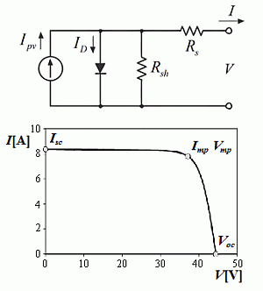

Figure 5. Equivalent solar cell circuit and VI curve [36]

*Figure* *5* above shows the equivalent circuit model for a photovoltaic solar cell along with the nonlinear current-versus-voltage (I-V) curve. For voltages below that at the maximum power point (MPP), labeled as the pair (Imp­, Vmp), the output current of the solar cell remains constant at the short-circuit current (Isc). For voltages exceeding that at the MPP, the current rapidly decreases until reaching zero corresponding to the open-circuit voltage (Voc).

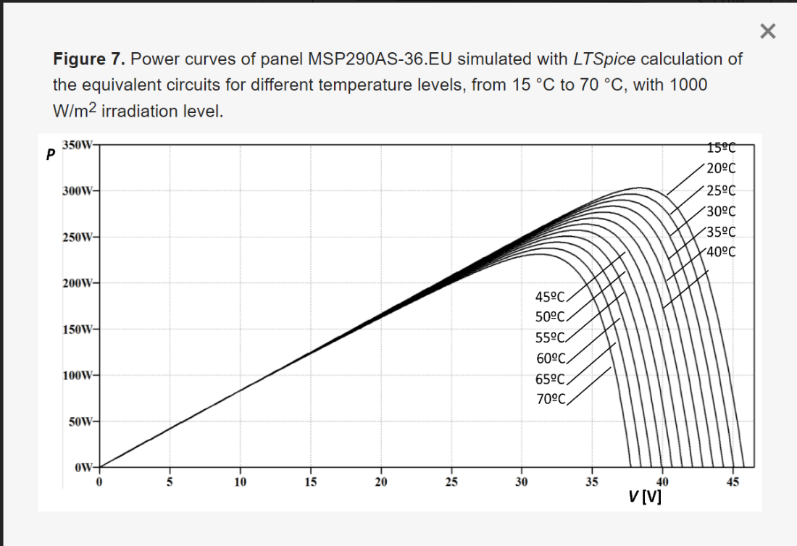

Figure 6. Example power curve of a solar cell [36]

*Figure* *6* above shows a set of power-versus-voltage (or power) curves varying with temperature. Much like how the voltage-current relationship of a solar cell is nonlinear, as shown in *Figure* *5*, the power curve also exhibits a nonlinear shape. The maximum point on the power curve corresponds to the MPP, which is the desired operating point to ensure maximum power is being delivered from the solar cells to the load or battery system. For voltages below that at the MPP, the power-versus-voltage relationship is approximately linear. However, as voltage increases past that at the MPP, the power output rapidly collapses.

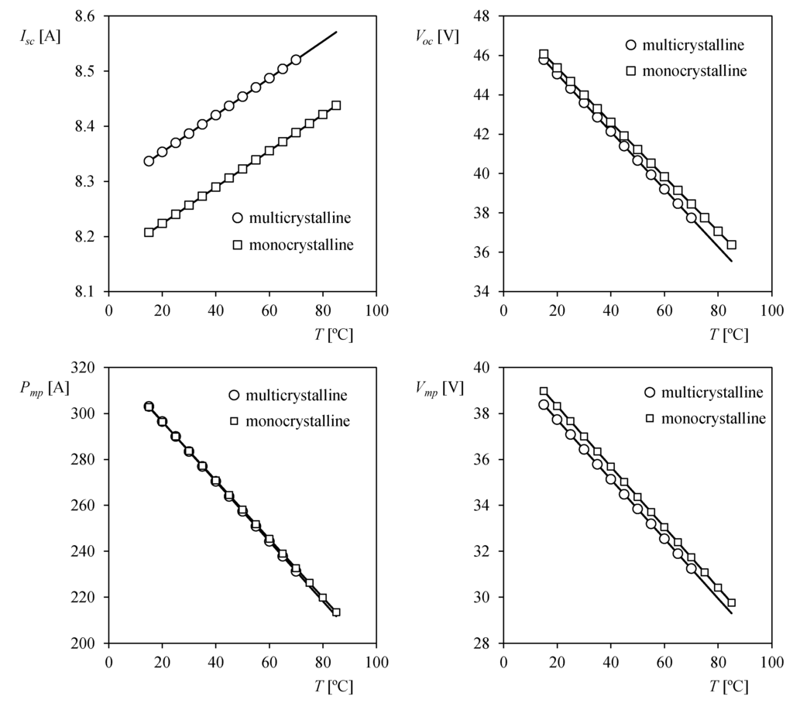

Figure 7. Example power variations of crystalline structures at different temperatures [36]

*Figure* *7* shows multiple plots of temperature vs. short-circuit current, open circuit voltage, optimum operating power, and MPP operating point voltage. This figure gives a brief overview of what one may expect of the performance of monocrystalline versus multicrystalline (or polycrystalline).

The following equations (9) through (13) all originate from [36] and are used to obtain the equivalent model parameters for the PV array shown in *Figure 5*.

$I= I_{pv}- I_{0}\left[\exp\left(\frac{V+IR_{s}}{aV_{T}}\right)-1\right]-(\frac{V+IR_{s}}{R_{sh}})$ (12)

$V_{T} = \frac{nkT}{q}$ (13) $\frac{aV_{T}V_{mp}(2I_{mp}-I_{sc})}{\left(V_{mp}I_{sc}+ V_{oc}\left(I_{mp}-I_{sc}\right)\right)\left(V_{mp}-I_{mp}R_{s}\right)-aV_{T}(V_{mp}I_{sc}- V_{oc}I_{mp})}=exp⁡(\frac{V_{mp}+ I_{mp}R_{s}-V_{oc}}{aV_{T}})$ (14)

$I_{0}= \frac{\left(R_{sh}+ R_{s}\right)I_{sc}-V_{oc}}{R_{sh}*exp⁡(\frac{V_{oc}}{aV_{T}})}$ (15)

$I_{pv}=\left(\frac{R_{sh}+ R_{s}}{R_{sh}}\right)*I_{sc}$ (16)

Some important variables to understand in the above equations (12) through (16) are V (voltage), VT (thermal voltage), Rs (series resistor accounting for solar cell bond loss), Rsh (shunt resistor that accounts for current leakage), I0 (reverse saturation current corresponding to the diode of the circuit in *Figure* *6*), and Ipv (photocurrent delivered by the current source). Equation (13) represents the thermal voltage, where *k* is the Boltzmann constant, *T* is the temperature, and *n* is the number of cells in series. Equation (14) for which each of the variables are determined from the parameters as defined per datasheet, accounts for the presence of series model resistance Rs. It should be noted that parameters Voc and Isc refer to the open circuit voltage and the short circuit current of the PV cell, respectively. Equations (15) and (16) provide expressions for the reverse saturation current I0 and the photocurrent Ipv in terms of the PV cell model parameters, respectively.

## ***Circuitry***

Off-grid solar-powered electrical systems requiring a battery often must have circuitry which optimizes both the charging/discharging of the battery and the extraction of power from the photovoltaic (PV) solar array. The absence of such circuitry may manifest as inefficiency in terms of the power delivered from the PV array to the batteries but also as damage to the batteries if they become overcharged or over discharged. Thus, one candidate technique for solar charge control has been explored, which is called Maximum Power Point Tracking (MPPT), in addition to several battery charge control schemes including constant voltage (CV), constant current (CC), and two-stage (CC/CV).

The MPPT solar charging technique can be implemented using one of three common algorithms, which include Perturb & Observe (P&O), Incremental Conductance (IC), and Fractional Open Circuit Voltage (FOCV) [37]. The premise of MPPT solar charging is to ensure that the maximum power output from the PV arrays is always achieved to help reduce wasted energy and increase the lifespan of the attached battery system. In practice, PV arrays work in the exact opposite manner as a light-emitting diode (LED): an application of light or solar energy to the silicon semiconductor material generates a current through the silicon [38]. The result is a nonlinear relationship between the output voltage and the output current of the PV array, implying that a balance must be struck between output voltage and output current to ensure stable power delivery to the battery system. According to an example I-V characteristic curve for a PV array from [36], a sufficiently large voltage will result in a collapse of the output current and subsequently a reduction in the output power. The MPPT solar charging algorithms take advantage of this nonlinear I-V relationship to actively adjust the output power such that it always resides about the maximum power point (MPP) along the plotted I-V curve. While effectively accomplishing the same task, the three MPPT solar charging algorithms each have advantages and disadvantages in terms of complexity and efficiency.

The simplest of the three algorithms, fractional open-circuit voltage (FOCV), is the simplest and easiest to implement MPPT algorithm, according to [39] and [40]. The FOCV algorithm involves taking a measurement of the open-circuit voltage (OCV) of the PV solar array, then regulating the input to the battery system at a certain percentage of the OCV [41]. The OCV is the voltage measured across the output of the PV solar array without being connected to any load. According to [37], the comparison between the measured PV array voltage and the open circuit voltage controls the duty cycle of a DC-DC converter circuit at the PV array output to achieve a constant fraction of the OCV. This constant fraction of the OCV corresponds to the maximum power point of the PV array. The advantage of this system, according to [39], is that it is easily implemented with a single microcontroller and voltage sensor. However, a tradeoff is made in that there is a lower tracking speed and a lower output efficiency compared to the other two MPPT algorithms [37].

The next least complex MPPT algorithm is Perturb & Observe (P&O). As the name suggests, this algorithm involves systematically perturbing the output voltage of the PV array until the MPP is found. According to [41], both the current and the voltage from the PV array are measured using a microcontroller or equivalent device. Current can be measured by measuring the voltage across a known sensing resistor, or sometimes referred to as a shunt, then dividing the voltage by the sensing resistance. Instantaneous power is calculated by taking the product of measured current and voltage, which is then compared to a prior measurement/calculation of power [41]. If the power increased from the last measurement, the microcontroller checks if the voltage increased. If the DC output voltage did increase, the microcontroller allows the voltage to increase further to become closer to the MPP. If the DC output voltage did not increase, then the increase in power is likely due to an increase in current and the voltage is decreased.

A similar adjustment is made if the measured power is less than the prior measurement, ensuring that the adjustments in current/voltage always bring the output power closer to the MPP [41]. The presently measured power is then set to be the prior measurement value for future comparison. The P&O algorithm is a reasonably simple option that can be implemented with one microcontroller, as was done using an Arduino in [41]. However, the disadvantages of this algorithm reside within the oscillations of the output power around the MPP as the algorithm tracks the MPP, an inability to react to rapidly changing weather and irradiance conditions, and low efficiency at low irradiance (low light) conditions [39]. The impact of the oscillations could be mitigated by controlling the sampling rate of the voltage and current, but it is likely that the inherent processing time of the voltage/power comparisons will limit the sampling frequency. Poor reaction time and efficiency resulting from external conditions such as weather and irradiance levels are more difficult to mitigate, which could lead to system failure under these unideal conditions.

The most complex algorithm out of the three studied MPPT algorithms is Incremental Conductance (IC), according to [37]. IC takes advantage of the nonlinear power-versus-voltage characteristic curve of the PV array by observing the derivative of the panel output power with respect to the output voltage (or the change in output power with respect to the change in output voltage). When this derivative is zero, the slope of the power-versus-voltage curve is also zero, implying that the MPP has been achieved. Direct computation of this derivative with traditional microcontrollers is not possible, however a comparison can be made between what is called instantaneous conductance and the incremental conductance [37]. The instantaneous conductance is equal to the ratio of instantaneous current to instantaneous voltage ($\frac{I}{V}$) while the incremental conductance is equal to the ratio of the change in (or incremental) current to the incremental voltage ($\frac{∆I}{∆V}$). The relationship between the incremental conductance and instantaneous conductance indicating that the MPP has been reached is as follows [37]:

$\frac{∆I}{∆V}= -\frac{I}{V}$ (17)

The IC algorithm developed by [37] employs a similar measurement of the voltage and current as is used in the P&O algorithm, but the resulting comparison operations are considerably different. Instantaneous power is calculated from the measured voltage and current in addition to the change in the voltage between the most recent and prior voltage measurements. Then, the change in current with respect to the change in the voltage (assuming ΔV is nonzero) is evaluated to see if it meets the criteria outlined in equation (17). Until the condition in equation (17) is satisfied, the algorithm adjusts the output voltage and output current (via increment and decrement operations) [42]. Once the algorithm tracks that the slope of the power-versus-voltage curve is zero through the sample/increment/decrement operation, the system is maintained at that operating point (barring any external changes to weather, temperature, or irradiance) [42]. The advantages of the IC algorithm are a faster converging/settling time and higher efficiency but are met with the glaring disadvantage of computational complexity resulting from having to solve the differential equation shown in equation (17) [37].

The study of various MPPT algorithms provides the option to design a solar charge controller solution that is better tailored to the final solar luggage cart system. However, even with the simplest algorithm, FOCV, designing a solar charge controller from scratch would likely not fit the time constraint for the project. Off-the-shelf solar charge controllers, such as what is offered by [43], do offer MPPT implementation, despite not revealing which algorithm is used, which could help expedite the design process. Further, solar charge controllers designed for off-grid usage often incorporate a battery charging scheme, which will assist the MPPT algorithm in extending and optimizing the lifecycle of the battery system. A characterization of three battery charging schemes (constant current, constant voltage, and two-stage charging) will assist in evaluating the best possible charge controlling scheme based upon the selected battery and PV array chemistry.

Constant voltage (CV) charging involves supplying the battery with current to achieve a constant set-point voltage (which is pre-determined by either the manufacturer or system designer), after which a small amount of current is sourced to maintain this constant set-point voltage [44]. According to [45], CV charging has a longer charging time, but this is necessary to maximize the lifespan of the battery system. Further, research by [45] of other CV solutions found that the capacity degradation (the reduction in the total energy capacity that the battery can store) was lower in CV than other charging schemes. In terms of complexity, this charging scheme is relatively simple as it only requires the charging current to be monitored once the set-point voltage is achieved. Constant current (CC) charging provides a constant charging current to the battery until a pre-determined cut-off voltage is achieved [45]. By itself, CC charging cannot achieve a full 100% state-of-charge (SoC) of the battery due to the cut-off voltage being achieved when the current is still held constant [45]. CC/CV charging seeks to combine the individual CC and CV charging schemes to help mitigate the shortcomings that each exhibited by themselves.

For CC/CV charging, the charging current is initially held constant while the battery voltage is allowed to rise [45]. Once the battery voltage reaches a pre-determined cut-off value, the charging current decreases until the battery SoC reaches 100%. The downside to CC/CV charging is that it incurs a higher capacity degradation rate than the other two individual CC and CV methods but can be mitigated by increasing the time in which the battery charging is in the CV mode [45]. It should be noted that the above charging schemes were described in [45] for use in charging lithium-ion batteries, implying that the battery charging scheme is dependent upon the chemistry of the battery and the environment within which it resides. The common factor among all battery charging schemes, however, is the need for DC-DC conversion or DC regulation circuitry.

DC-DC conversion is the conversion of DC voltage at one level to DC voltage at another level, either higher or lower. Further, DC-DC conversion can be used to help keep the voltage in a circuit at a constant value – a useful feature especially when dealing with the battery charging schemes described above. Two common types of DC-DC converter circuits, or sometimes referred to as switching regulators, that were found to be used in solar charge and battery charge control circuits were boost and buck DC-DC converters.

Figure 8. Example of boost converter circuit in a solar charge controller [40]

*Figure 8* above shows a boost converter circuit at the output of a PV array, which is used to help regulate the PV output to properly drive the load. A boost converter is a DC-DC converter which takes an input DC voltage at a lower value and outputs a DC voltage at a higher value [43]. In the boost converter circuit of *Figure 8*, there are two linear circuit elements (a capacitor and an inductor), a transistor operating as a switch, a diode, and a connected load modeled by a single resistor.

Figure 9. Boost converter topology and circuit operation [46]

*Figure 9* [46] above shows the same boost converter topology as in *Figure 8*, but with additional equivalent circuit diagrams to show the principle of operation. The transistor in the boost converter circuit is operated using a PWM signal, which can have its duty cycle adjusted to adjust the on-off time of the transistor switch. When the switch is ON (i.e., the PWM signal is HIGH and the transistor is allowed to conduct, in this case, from the collector terminal to the emitter terminal), the inductor is allowed to charge from the input voltage source according to the following equation (18):

$v=L* \frac{di}{dt}$ (18)

where *v* is the voltage across the inductor, *L* is the nominal inductance, and *i* is the current through the inductor. When the switch is OFF (i.e., the PWM signal is LOW and the transistor is prevented from conducting from the collector to the emitter), the inductor releases its stored energy through the diode (which is forward-biased), charging both the parallel capacitor (to a voltage higher than the input) and providing current to the load [46]. When the switch is turned ON again, the diode becomes reverse-biased, allowing the capacitor to discharge its stored energy into the load without feeding the energy back to the input.

The other common type of switching regulator, the buck converter, was used by [37] to implement an MPPT-based charge control circuit. The buck converter topology and equivalent circuits used to display its functionality is shown below in *Figure 10* [46].

Figure 10. Buck converter topology and circuit operation [46]

The buck converter shown in *Figure 10* works in the opposite manner of the boost converter shown in *Figure 9* in that it takes an input DC voltage and provides at its output a DC voltage that is lower than the input. The same components used in the boost converter are used in the buck converter, but the orientation and connection of the components is rearranged. Initially, when the transistor switch is turned ON, the inductor and the capacitor are allowed to charge up from the input voltage source. When the switch is turned OFF, the inductor is completely disconnected from the supply voltage. By limitation imposed by the current-voltage relationship for the inductor in equation (18), the current through the inductor cannot change instantaneously [46]. The result is that the current through the inductor decreases slowly until the voltage at the “input” or “left” end of the inductor drops sufficiently to forward-bias the diode [46]. Both the capacitor and inductor provide current to the load when the switch is OFF. The lowered output DC voltage is a result of the inductor being completely disconnected from the input voltage source during the switch OFF period.

The solar charge control circuitry will ultimately comprise of three separate components: an MPPT algorithm controller, a DC-DC converter, and a battery charge controller. As stated previously, off-the-shelf solutions may offer the desired specifications in terms of solar panel output efficiency and battery lifespan without requiring a complex, original design. Therefore, knowledge of the above concepts is crucial for choosing a solar charge controller that will properly interface with both the PV arrays and the battery system for recharge management purposes.

# **Problem Statement**

Existing electric luggage carrier vehicles utilize plug in, on-grid charging, powered by environmentally harmful, non-renewable resources. An electric luggage carrier vehicle equipped with a renewable, self-sufficient, off-grid charging method is desired.

# **Project Objective**

The objective is to deliver a proof-of-concept off-grid, solar-powered electric cart by December 2023 that demonstrates the potential to tow up to 3400 kilograms.

# **Requirements**

1. **The system will comprise of a solar-powered driving cart and a towed luggage cart capable of carrying a load on mostly flat, relatively smooth surfaces, to a destination.**

*Rationale: Luggage carts in airports run throughout the day, and creating a solar-powered* *cart has the potential to reduce carbon emissions and minimize costs spent on the usage of fossil fuels.*

1. **The vehicle shall be operated using only battery power.**

*Rationale: The hub motors that allow the vehicle to move must be supplied with power separate from the main powered grid. Batteries offer a portable means of powering such motors. This task was mandated by the client, Professor Samson Mil’shtein.*

1. **The vehicle battery system shall be recharged exclusively by the solar PV array.**

*Rationale: Current electric vehicle technology requires recharging of any battery*  *system through the main power grid, which does not use renewable energy sources. This task was mandated by the client, Professor Samson Mil’shtein.*

1. **The battery should exhibit a maximum charging time of 16 hours.**

*Rationale: Typical charge time for a non-Lithium based battery is cited to be anywhere from 8-16 hours [28].*

1. **The battery terminal voltage should not exceed 48V.**

*Rationale: Battery voltage is proportional to the physical size and weight of the battery, so a maximum battery voltage must be defined. This task was mandated by the client, Professor Samson Mil’shtein.*

1. **The battery chemistry shall not be lithium-based.**

*Rationale: Lithium batteries are difficult to work with and are more flammable than other battery types, thus risking environmental and operator harm. This task was mandated by the client, Professor Samson Mil’shtein.*

1. **The area of each individual solar panel shall not exceed 1 m2.**

*Rationale: The vehicle roof will have limited area, so a maximum solar cell size must be defined. This task was mandated by the client, Professor Samson Mil’shtein.*

1. **The solar charge controller should use a Maximum Power Point Tracking (MPPT) based charging algorithm.**

*Rationale: Maximum Power Point Tracking ensures that the maximum power is being extracted from the solar PV array at any given time, accounting for changes in ambient temperature, irradiance, and other environmental changes. This task was encouraged by the team mentor, Jeffrey Snell.*

1. **The solar panel type may be thin-film – a type of flexible solar panel.**

*Rationale: The weight of the vehicle should be minimized as much as possible, therefore a flexible solar panel is strongly advised. This task was suggested by the client, Professor Samson Mil’shtein.*

1. **The vehicle must have an accessible and easy to operate power switch.**

*Rationale: A safe vehicle would allow the operator to turn off the system as conveniently as possible, because a less complicated design leaves less room for error.*

1. **The vehicle should be capable of operating for at least 15 hours.**

*Rationale: To meet the demands of luggage transportation at an airport, the luggage vehicle should be able to operate in a stop-and-go manner throughout a standard operating day at an airport. This will depend on the capacity of the chosen battery, power efficiency, and operation of the solar recharging system.*

1. **The vehicle shall utilize hub motor technology.**

*Rationale: Hub motors are affordable, small, and efficient, and decrease the mechanical complexity of the system. This task was mandated by the client, Professor Samson Mil’shtein.*

1. **The vehicle should be capable of carrying a rated load of 1200 kg (2500 lbs.) with one towed cart.**

*Rationale: According to the project client, Professor Mil’shtein, a full-scale luggage transport vehicle used at an airport can carry 150 luggage bags, each weighing 50 lbs. for a total weight of 3400 kg (7500 lbs.). Assuming a full-scale system of three towed luggage carts accommodating such a load, this full weight of 3400 kg is divided by three to obtain the rated luggage weight required for the scaled-down one-cart prototype vehicle.*

1. The vehicle should be capable of carrying a minimum load of 340 kg (750 lbs.) with one towed cart.

*Rationale: With the standard maximum luggage weight of 50 lbs. per luggage bag, the weight requirement listed above (340 kg/750 lbs.) assumes 15 bags each weighing 50 lbs.*

1. **The vehicle should be able to achieve a maximum speed of at least 16 kph (10 mph) and must be able to do so under full load.**

*Rationale: Although aircraft are usually loaded near the airport terminal, the vehicle may need to travel considerable distances. The maximum speed of the vehicle must therefore be fast enough to ensure timely arrival at the luggage destination but not so fast that harm could be caused to the operator or pedestrians. A maximum speed of 10mph, while not very fast, is a moderate balance between these two concerns.*

1. **The vehicle shall be equipped with a braking system operated by a brake pedal.**

*Rationale: A hydraulic or mechanical brake must be included to ensure that the vehicle can make a controlled, emergency stop if required. This requirement was mandated by the project client, Professor Samson Mil’shtein.*

1. **The vehicle should achieve a stopping distance of 10 meters under maximum load.**

*Rationale: A known stopping distance is important to ensure the safety of the operator and those around them.*

1. **The vehicle must have an accelerator pedal capable of initiating a constant acceleration to reach the vehicle’s maximum speed.**

*Rationale: Constant acceleration of the luggage vehicle will minimize operator and passerby injury but will also ensure a stable current draw from the battery system by the driving motors.*

1. **The vehicle shall be capable of turning using a steering wheel that operates smoothly.**

*Rationale: The cart must be able to move in all directions to accurately load and unload luggage. The given turn radius is a typical measurement in cars.*

1. **The vehicle should allow a single cart to be connected quickly and easily.**

*Rationale: Quickly connecting carts allows less time to be allocated to setting up the system, and a system designed to be connected and disconnected leaves less room for error.*

1. **The vehicle shall have a manual emergency stop system that disconnects power from the actuators.**

*Rationale: In the event of an emergency, no electricity should be supplied to the motors or any other moving part. Unexpected movement of the vehicle is dangerous and can cause injury to operators and passersby in direct proximity. This feature should be activated manually by the operator as autonomous emergency shut down is outside of the scope of this design.*

1. **The vehicle should be capable of driving in reverse.**

*Rationale: The vehicle may require moving in reverse to align the luggage cart with a loading dock, eliminating the need for the vehicle to drive a loop to turn around or maneuver around obstacles.*

# **Design and Analysis**

## ***Analysis of multiple designs***

## ***Mechanical Design Alternatives:***

Due to the wheels being directly driven by the motors, there are no gears, bearings, or differentials adding complexity to the drivetrain of the system. Consequently, motors on the same axis must be able to spin at different speeds or the wheel on the inside of the turning radius needs to be turned off to remove unnecessary wear on the tires and the motors themselves. This algorithm would need to take into consideration the turning radius and speed at which the cart is traveling, and perform quick calculations for different motor speeds. The complexity of the math increases as more than two driving wheels are taken into consideration.

For the driving configuration of the system there are three option sets that need to be decided on, two-wheel or four-wheel drive and if the towed carts should be driven as well. First, the two-wheel drive option would reduce the complexity of the circuitry and the turning algorithm, but it would increase the necessary torque of each drive wheel, resulting in more expensive motors and controllers. A four-wheel drive system would increase the complexity of the circuits and the turning algorithm, but it would also divide the driving torque of each motor of the two-wheel system by two. This would allow for less expensive, lower powered motors and increased traction during nonideal weather conditions.

Figure 11. Possible wheel orientation for luggage cart front axle assembly

Another configuration to consider is powering the towed carts. A small motor could be outfitted to the carts to assist the driving cart during towing. As seen in *Figure 11*, a triangle frame with wheels at reach vertex could be placed in the front of the towed carts. The forward wheel would be powered by a hub motor, and the other two would be free spinning on bearings. This has the added stability of a four-wheel system but allows for easy integration with the motor. The advantage this would provide is increased efficiency in power usage as all carts would accelerate together, instead of the driving cart using very high power to get the carts rolling. This will allow the driving cart to have lower-power motors instead of motors with large power demands, which would lower the cost of the motors, but would require the use of a greater number of motors.

In terms of the solar and battery systems, more solar panel area and available energy storage is desirable. One of the possibilities for the towed carts is to have their own dedicated solar charging system and battery array. Doing so would allow for the carts to run their own motor, and not create added load to the driving cart’s battery array. Adding batteries to the towed cart will increase the weight of the system, but the advantage of the towed cart’s ability to assist the driving cart with moving the system at max capacity, has potential to be worth the extra weight.



## ***Battery System Design Alternatives:***

The benefits of electrical energy provided by batteries offer several advantages as well as drawbacks. Rechargeable batteries with specific chemical makeup lead the way for electric vehicles because they are simple and cost-effective [47]. Power density and energy efficiency depend on the battery type; however, this does not necessarily mean increased power is better for all applications. Modern technology currently prefers the advantages of lithium batteries as opposed to lead-acid and nickel-cadmium. The lithium battery is preferable in modern technology is it offers the best quality [47]. Lithium batteries tend to weigh the least compared to competitors, as well as having a low discharge rate, a long-life cycle, and a quick charge rate. [47] All of these advantages are preferable over the fact that lithium batteries are the most expensive and desired battery type on the market. Since efficiency and power capability are highly valued in modern technology due to increased market demand, this just happens to fit the role. Unfortunately, though, a requirement of this project is to avoid the use of lithium batteries, so despite their advantage, other batteries will be considered over lithium due to cost and environmental safety. Lithium battery technology, however, was preceded by lead-acid and nickel-cadmium batteries, which were, up until recent years, the preferred battery choice.

Lead-acid batteries, contrary to lithium, weigh the most, require the most maintenance, have the least energy efficiency, and “poor temperature characteristics” [47]. They are, however, very reliable and predictable batteries, as evidenced by their long-time presence in technology. Lead-acid batteries also have the most options for prioritizing certain characteristics. For example, there are Flooded, Absorbed Glass Mat (AGM), and Gel subsets of battery chemistry. Deep cycle batteries are also a popular option due to the increased demand in long-term energy storage. Lead-acid batteries however are preferred as the most cost-efficient solution to electric vehicle technology [29]. According to *Figure 12* they also have the least self-discharge and the most cell voltage and overcharge tolerance. If battery maintenance is not an important consideration but battery replacement is, then this may be viable. Nickel-cadmium batteries are like lead-acid batteries; however, they have a longer life span and better energy characteristics [47].

For frequent charge-discharge applications, though, nickel batteries are not preferable. Nickel-cadmium batteries are also banned because cadmium is a harmful substance to the environment. “[Nickel-cadmium]’s biggest disadvantage is the use of a heavy metal (Cadmium) in the construction, with harmful effects on the environment and human and animal health. EU directives limit the use of this type of battery” [29]. Nickel cadmium batteries are still a viable option outside of Europe however lead acid batteries are heavily favored due to their options on the market right now.

Aside from the characteristics of these batteries, a certain battery rating must be chosen. The value of these battery ratings depends on the requirements of the system. The battery capacity is dependent on the amount of energy that the system needs, and thus determines the amount of power that will be generated. Similarly, the current and power ratings are important for what power is produced by the battery and for how long the battery can be discharged before becoming fully depleted.

As seen in *Table 4*, the current draw is proportional to respective voltage ratings. To be able to draw as small of a current as possible per kilowatt, the maximum voltage rating should be picked – 48 volts. This is the maximum rating because it is compatible with the system, and any greater battery system voltage may incur unnecessary weight and electrical losses from any required DC/DC conversion. To meet the requirements of the hub motors and the large amount of power that they consume, it is ideal to gain as much power as possible for the least amount of current. More current means that the system is susceptible to more heat, which could prove hazardous to passengers of the cart. Additionally, space is a premium of this system, therefore more current requires larger components and battery capacity, which are simply not available. *Figure 12* provides valuable insight into the quantifiable conditions for which four different types of batteries can operate at. The lead acid battery, for example, must be “thermally stable” for safe use [28]. Although Lead-Acid is beaten by Nickel-Cadmium (NiCd) and Nickel Metal Hydride (NiMH), the fact that its maintenance cycle is not as frequent makes it a strong contender.

Table 4. A/kW ratings for varying battery voltages

|  |  |
| --- | --- |
| Voltage (V) | Current (A/kW) |
| 12 | 83 A/kW |
| 24 | 42 A/kW |
| 36 | 28 A/kW |
| 48 | 21 A/kW |

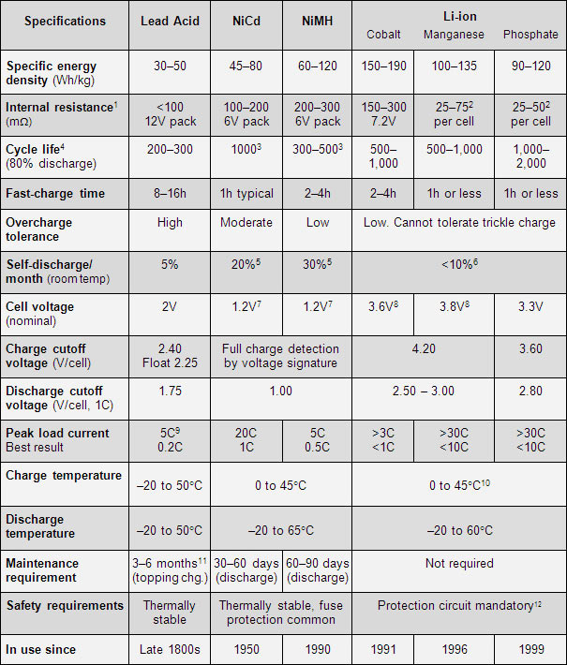

Figure 12. Battery characteristics by type [28]

Even though the data provided suggests that lithium-ion or even nickel batteries are optimal battery technologies, this data comes from a large range of assumptions that may not apply to this solar powered charging system. There are also certain characteristics that are accounted for by evolving lead-acid battery technology. Lead-acid batteries also have some of the best capacities of batteries for this application, with 100 Ah and 200 Ah ratings being quite common. The following table offers a comparison of Gel and AGM batteries, which is the final comparison that must be made.

Table 5. Comparison of Gel and AGM batteries [48]

|  |  |  |
| --- | --- | --- |
| **Item** | **Gel／AGM** | **Comparison** |
| Electrical Performance | The pores of the gel structure are narrow, so the ions are more clogged, and the internal group of colloidal sealed lead acid batteries is larger than AGM. Therefore, AGM's high-power discharge performance is better. | AGM is better |
| Size | Gel electrolyte is 20% more than AGM, and it adopts flooded process, so AGM energy density is high | AGM is better |
| Ventilation Requirements | Gel is a flooded battery, the cracks generated by the gel provide oxygen circulation. Gel must be well ventilated. AGM has 8% of the gap in the separator, and no electrolyte is filled. | AGM is better |
| Thermal Runaway | The AGM sealed lead-acid battery adopts a liquid-lean design. In the separator plate, 8% of the porosity must be maintained and the electrolyte is not allowed to enter. Therefore, the internal heat of the battery is poor, and the oxygen generated during charging reaches the negative electrode, which generates heat. If you can't dissipate heat immediately, the battery temperature will increase. | Gel is better |
| Operating temperature | Gel working temperature adaptability is better than AGM | Gel is better |
| Cycle Life | AGM battery cycle life is about 400 times; Gel battery cycle life is about 600 -800 times | Gel is better |
| Standby Life | Both AGM and Gel can have a long-life design. | Both are good |

## ***Photovoltaic Design Alternatives:***

Depending on the specifications of the system, solar panels with varying characteristics may be chosen. The options are monocrystalline, polycrystalline, and thin-film. Thin-film is seeing a rise in popularity due to cost, weight, temperature resistance, and that they are easier to manufacture [47]. Due to the extreme weight requirements of the system, thin-film solar panels are the most likely solution. However, the one problem with this is that thin-film is historically low efficiency compared to its sturdy monocrystalline and polycrystalline counterparts. Polycrystalline is viable, especially because it is more affordable, but will not need to be considered due to focus on efficiency [30]. Monocrystalline is the slightly more costly option over polycrystalline, but since cost is the last concern of this project monocrystalline can comfortably be selected. According to [31], “Multicrystalline wafers are also cheaper, but they generally result in cells and modules with conversion efficiencies that are 2 to 4% lower than those obtained with monocrystalline wafers” [31]. Due to the goal of this project being incredibly power intensive, garnering as much power efficiency as possible is desired.

## ***Charge Circuitry Design Alternatives:***

The circuitry required to control the extraction of power from the solar PV array and to manage the charging/discharging of the batteries must take into consideration three important properties to assess the best design approach. These properties include assessing whether the solar charging will be implemented with a commercial device or a custom design, the choice of either a custom or commercial battery charge controlling scheme, and the presence of a DC/DC converter or other regulating circuit on the output of the solar PV array. The first general decision which must be made is whether an off-the-shelf, commercial solar charge control system or a custom designed solar charge control system will be used. In the case of a custom designed solar charge control system, finer control over the choice of maximum power point tracking (MPPT) algorithm will be possible, which could help to improve efficiency of the final system. However, a tradeoff between efficiency and complexity exists when implementing MPPT solar charge tracking, so the algorithm chosen to implement such solar charge control must be carefully selected.

The Fractional Open Circuit Voltage (FOCV) algorithm can easily be implemented with a single microcontroller and maintains stability of the solar panel output by setting the output of a DC/DC converter to a constant fraction of the measured solar panel open circuit voltage (OCV) [37] [41]. However, compared to the far more computationally complex Incremental Conductance (IC) algorithm, which utilizes a differential equation to locate the maximum power point (MPP), the efficiency of the solar PV array using the FOCV algorithm is lower [37]. The third algorithm, Perturb & Observe, seems to be a middle ground between the FOCV and IC algorithms in terms of complexity, but the oscillations it induces (by measuring the output current and voltage and adjusting them until reaching the MPP) on the solar panel output may not be desirable [39].

These considerations all disappear when utilizing an off-the-shelf solar charge controller, however, as most commercially available MPPT solar charge controllers will not likely advertise which algorithm is being used to maintain their place in the market. The monetary cost of a custom designed MPPT solar charge controller can be more easily minimized (through the selection of cheaper, but still effective components) than a commercial system. Efficiency could also be more finely controlled with a custom designed solar charge controller, as the algorithm can be precisely adjusted and chosen to ensure stable operation at the MPP. Custom designs may suffer from reduced resilience to extreme temperature or weather environments, which are commonly implemented features of commercial solar charge controllers. Lastly, from the perspective of project schedule, the reduced complexity of sourcing a commercial solar charge controller (which depending on the selected battery and solar panel voltages could easily interface between the two electrical subsystems with minimal external circuitry) could lead to a reduction in design and testing time.

In many cases, solar charge controllers also include a battery management system which employs a control scheme such as constant current (CC), constant voltage (CV) or two-stage (CC/CV) to ensure the battery is not overcharged or over discharged. The choice of battery control scheme regardless of the battery management system being custom designed or commercial, depends on the selected battery chemistry. Lead acid batteries, according to [49] are best charged using a constant-voltage, current-limited (like CC/CV) charging scheme, which maximizes battery life and capacity while minimizing recharge time and cost. Other charge control schemes can be used for lead acid batteries (such as either CC or CV standalone charging) at the expense of reduced battery life over time.

Lithium-ion batteries can employ similar charging schemes, but for two-stage charging, capacity degradation must be mitigated by increasing the time during which the charger is in CV mode [45]. Such adjustment of timing may not be possible with a commercial battery management system but could be achieved with a custom design. Further research conducted by [45] indicates that the standalone CC and CV charging schemes for lithium-ion batteries lack the inability to achieve 100% state of charge and require longer charging times, respectively. Like the solar charge controller, a custom design of the battery management system can help minimize cost, maximize efficiency, and possibly reduce system test time due to the design being tailored specifically to the final battery system. However, these benefits come at the cost of time spent researching, designing, and testing such a design, something which must be minimized for this project to be successful.

DC/DC converter circuits (such as boost or buck converters) could be used to help interface the solar PV array to the battery by regulating the solar panel output to match that of the battery terminal voltage. In principle, such a DC/DC converter could help broaden the criteria for battery voltage and solar panel output voltage, as a lower solar panel output voltage could be increased using a boost converter to match the chosen battery voltage. However, according to Ohm’s Law, if the voltage increases and the power draw (by the battery system and the hub motors) remains the same, the current must therefore decrease, which is not desirable considering that a sizable current is required for charging the battery. This problem can be easily mitigated by choosing a battery terminal voltage and a solar cell output voltage which are the same. A DC/DC converter may be required regardless choosing a custom designed or commercial solar charge/battery management system, however, to ensure that either constant voltage or constant current is being delivered to the battery to implement the selected charge control scheme.

## ***Motor Design Alternatives:***

Selecting the proper type of motor to design the system around requires balancing multiple categories to produce the best final product. The most important of these categories is the power source that is available to power the system, which determines what voltage the motor must run on. With the project requiring the use of batteries, the motor would most easily be DC, since no inversion would be needed. AC motors could be used, but it would require external circuitry to invert the battery voltage, introducing losses into the system. Selecting a DC motor would remove this issue, and the battery voltage could be applied to the motor without significant conversion. To keep the system as efficient as possible, the motor should be at the same voltage as the battery to avoid the use of a voltage conversion circuit, which would introduce loss into the system as well. Since the power of the system is the result of the supplied voltage and current, the chosen operating voltage would affect the current drawn to power the system.

With the selected motor leaning heavily towards being 48 V DC, the type of DC motor must be chosen, starting with whether the motor would be brushed or brushless. Because the brushes introduce a power loss into the system and damage more easily than brushless motors, a brushless motor is more efficient and lasts longer [12]. The brushless motor, however, must be controlled externally, through a specific motor controller or by a programmed microcontroller, which would introduce external circuitry [12]. The motor needs to move at different speeds regardless of whether it has brushes or not, so controlling circuitry is already necessary. For this reason, a brushless motor would be the best choice for this project, since the only negative for a brushless motor design is the charge controller, which is already required.

There are also different ways to produce the magnetic field in DC motors, the two main choices being a field produced with electric current and a field produced by a permanent magnet [12]. The current used to create the field would have to be supplied by the battery, which means the battery would have to have a higher capacity than if the motors were permanent magnets. One of the main difficulties of this project is power conservation, and it makes sense to select a motor with the least power supplied to it, and the best way to do this is to utilize a permanent magnet motor.

Finally, the construction of the motor must be considered, as the motor can rotate from the inside or from the outside. With a traditional motor, the inside of the motor would rotate, which is only useful when a gearing system is used, and that results in power loss [21]. When the outside of the motor rotates, the motor can be directly integrated into the wheel, which does not require a gearing system and can directly transfer the motor rotation to movement [21]. The best choice in this category is a hub motor because it is the most efficient configuration for this application.

Since a BLDC motor requires a controller [18], a suitable controller must be chosen. The motor controller must be capable of changing the motor polarity for every available motor pole and must be capable of variable speed. This can be accomplished with a commercially available solution that can supply the necessary power to each motor pole, or with a custom designed circuit. The off-the-shelf solution requires the least amount of effort to design and would just need to be connected and configured properly. The alternative is to design a circuit consisting of a type of programmable logic controller that can change the motor polarity at the appropriate times, which requires more design. The logic controller needs to be programmed, and the logic needs to interface with high voltage and high current, so a series of power transistors must be used. This solution allows for reprogramming, which lets the motor speed, acceleration, and direction be programmed exactly as necessary for this application and offers significantly more freedom for the rest of the design. This option is far more useful than an off-the-shelf motor controller, and the difficulties in designing and programming a motor controller are offset by the better control of a custom solution.

## ***Chosen solution:***

For the final mechanical design, the system will have a two-wheel drive driving cart, as well as a single motor on the towed luggage cart to assist in towing. Towed carts should also have their own charging systems and motor controllers with the driving cart providing the towed carts with the controller logic. This allows for the solar panels and batteries to be put on the trailing cart, increasing the capacity of the cart.

For the design of the battery system, AGM batteries will most likely prove better in long term solar power applications, given that they have better electrical performance. This factor is enhanced when the battery is a deep-cycle battery. Therefore, the best battery option for this system is a deep-cycle, AGM lead-acid battery, of 12 V. Although 48 V is more desirable for a battery in this system, commercially available batteries are unable to provide the daily capacity of roughly 520 Ah that is needed. One achievable system is to put four 12 V batteries in series to simulate 48 V, which will be done in this system.

The solar system will consist of monocrystalline type thin-film solar panels, which balance between high-efficiency and low-weight and are most appropriate when weight is a large issue. A commercial solar charge controller employing an MPPT solar charge algorithm and integrated battery management circuitry will be used to interface the PV array with the battery system. The selected solar charge controller must be compatible with AGM lead-acid batteries and be capable of producing a system voltage of 48 V at its output. Ideally, such a charge controller will accept 48 V at its input so that minimal active circuitry (DC/DC converters) is used, thus preventing power loss/reduction in current. This, however, depends on the arrangement of the PV cells and on the specifications of the selected solar charge controller.

The motor system depends on the power that the system needs to produce, and the motors need to generate enough power to move the cart. The power the system needs to provide can be estimated using equations (4) and (5), which when combined produce the following:

$P = F_{t}*v$ (19)

$P = m*a*v$ (20)

where P is the power of the entire system in Watts (W), Ft is the force to move the object, which can be approximated as the mass of the system (m) multiplied by the desired acceleration (a), and v is the maximum velocity of the system. Assuming a max acceleration of 1 m/s2, a top velocity of 5 m/s, a cart mass of 4000 kg total between both carts, and a towed mass of 1100 kg of luggage, the system would need to provide approximately 25.5 kW of power, which can be divided by two driving wheels for a total per wheel of 12.75 kW, and 8.5 kW for 3 wheels.

From the reasoning above, the motor used in this system should be at least 13 kW if two driving wheels are used, and 9 kW for 3 wheels. The motor should be a 48 V BLDC permanent magnet hub motor, which is the most efficient option according to the current per power calculations of *Table 4* and will greatly reduce the mechanical complexity of the final system. The motor should be controlled by a custom designed motor controller, which would allow for the most customization.

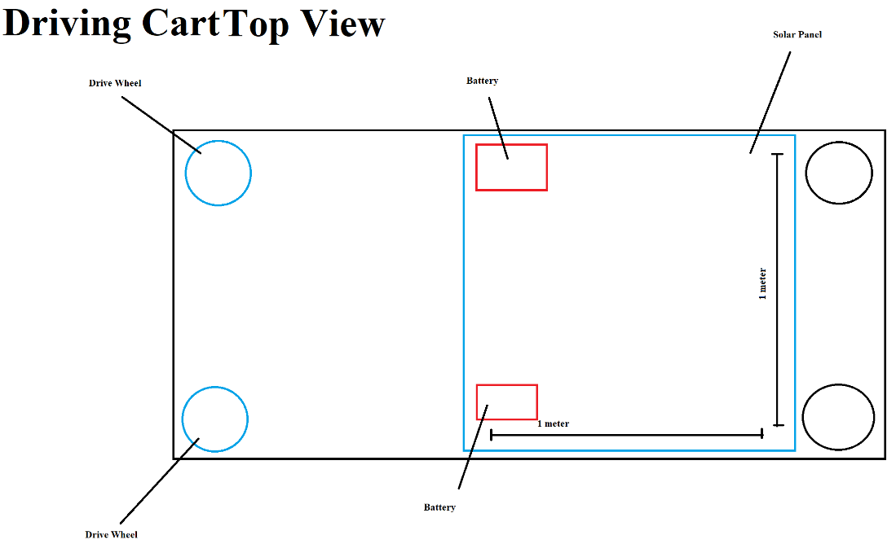

Figure 13. Diagram of physical driving cart (top view)

*Figure 13* shows a rough design idea for the driving cart, including the two hub-motor powered wheels at the front, two batteries mounted at the mid-point to balance weight, two non-powered wheels at the back, and the solar panel mounted on the top.

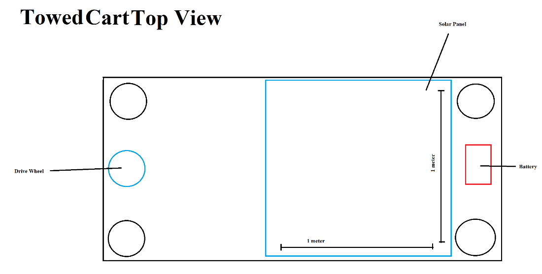

Figure 14. Diagram of physical towed luggage cart (top view)

*Figure 14* shows a rough design idea for the towed luggage cart. It contains only a single driving wheel placed in the front-center in between two non-driving wheels to maintain stability and balance. It also only uses a single battery placed at the rear of the vehicle to balance the weight.

1. ***Electrical Schematic***

## ***Block Diagrams***

Figure 15. High-level electrical block diagram

*Figure 15* above is a high-level block diagram detailing each sub-component of the electrical circuitry for the solar-powered luggage vehicle. The topmost blocks (Solar Cell System, Lead-Acid Battery System, and DC Bus) comprise the vehicle power supply system. Two solar cells and 48 V lead-acid battery systems will be used, with one solar cell system and battery array placed each on the driving cart and single towed cart. The idea of using two separate solar and battery arrays is that there will be more power available to drive the motors on the driving cart and the towed luggage cart and it will allow for implementation of the proposed continuous battery recharging system. All interconnecting arrows in the above *Figure*  which are red denote power transfer over the 48 V DC bus between each block, whereas interconnecting arrows which are blue denote low-voltage signals transmitted between two blocks (whether this be a digital voltage signal conveying binary data, or a pulse-width modulated or PWM signal).

A microcontroller powered from a 5 V DC power supply (likely an Arduino Mega due to the large GPIO pin count on this microcontroller) will serve to assist with battery charge control and with the control of the hub motors. Since BLDC motors are being used to drive the vehicle, the microcontroller will need to output PWM signals to control the motor speed. Further, the low-power (500 W) hub motors which were provided by the project mentor, Professor Samson Mil’shtein, have associated motor controllers which interface with Hall-effect sensors on the motors for position detection of the rotor. The microcontroller (and the motor control logic circuitry) must be able to read the Hall-effect sensor data to determine the angular position of the rotor to control which stator winding needs to be energized to keep the rotor moving in the same direction. Lastly, a vehicle control system (comprising of a steering wheel, accelerator pedal, and brake pedal) must communicate with the microcontroller to properly control the BLDC motors depending on which pedal was pressed by the operator.



Figure 16. Low-level electrical block diagram

*Figure 16* above shows a more detailed electrical block diagram translated from the high-level electrical block diagram of *Figure 15.* The 48 V battery arrays will each comprise of five 12 V, 200 Ah, lead-acid batteries, four of which will be connected in-series to produce the system voltage of 48 V. The fifth battery will be recharged through the solar panels while the vehicle operates on the remaining four batteries in the battery array. In this way, the battery with the lowest state of charge can be swapped out from the battery and recharged until the next battery needs to be recharged. The dark blue MOSFET blocks in the above image connected to the battery arrays are high power MOSFETs (or MOSFETs capable of handling large currents and voltages). One MOSFET is connected in-series with both the positive and negative terminal of each battery. This allows for each battery to disconnect from or reconnect to the 48 V battery array depending on its state of charge. The gray MOSFET blocks will be low power MOSFETs connecting each battery directly to the solar panel output for recharging. Thus, the MOSFETs connecting a battery in-series with the array must not conduct when the MOSFETs connecting the battery to the solar panel output are conducting. The “+” and “-“ symbols on the gray MOSFET blocks indicate which battery terminal/solar panel output (either positive or negative) .The output of the battery arrays form the 48 V DC bus and the DC GND bus, which is used to provide power to the other devices within the system.

The singular “Microcontroller and Logic” block in the high-level block diagram of *Figure 15* was subdivided into two separate microcontrollers and a separate hardware logic circuit block (both of which are shown in yellow). One microcontroller will be used to control the MOSFET switches for the battery/solar arrays while the other microcontroller will handle the PWM control of the motor and the sensor data processing from the operator controls. The high power MOSFETs connected to each BLDC motor will either energize or de-energize (depending on whether the MOSFETs are conducting) the winding on each of the three phases according to the output of the logic network. Two MOSFETs are connected to each phase of the BLDC motor, with one in-series with the “positive” terminal” and the other in-series with the “negative” terminal “ of the respective winding. The logic network takes as an input the PWM signal output from the motor control microcontroller as well as the Hall-effect sensor output signal from the BLDC motors. In this way, the logic network ensures that the correct phase is energized in the BLDC motor to allow for the motor to rotate in one direction continuously. The operator control block has been subdivided into the accelerator pedal, brake pedal, and steering to account for the separate data coming from each user control. Lastly, each microcontroller (and the logic network) is powered from a 5 V power supply created from the existing 48 V system voltage.

***Schematic Sheets***

Figure 17. Battery charging for array 1 schematic sheet (1 of 5)

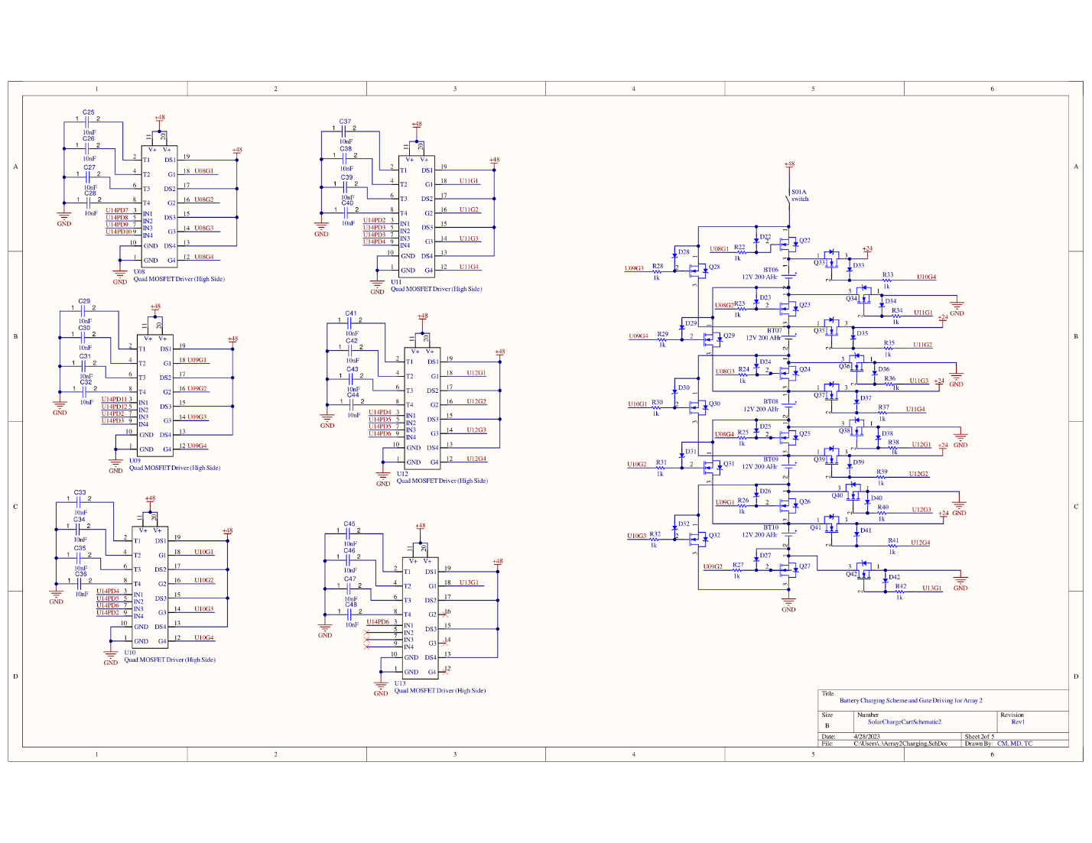

Figure 18. Battery charging for array 2 schematic sheet (2 of 5)

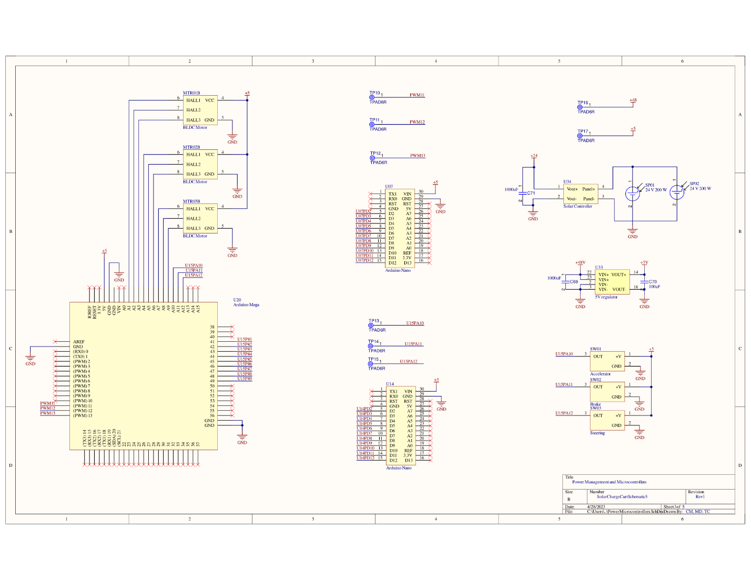

Figure 19. Power management and microcontrollers schematic sheet (3 of 5)

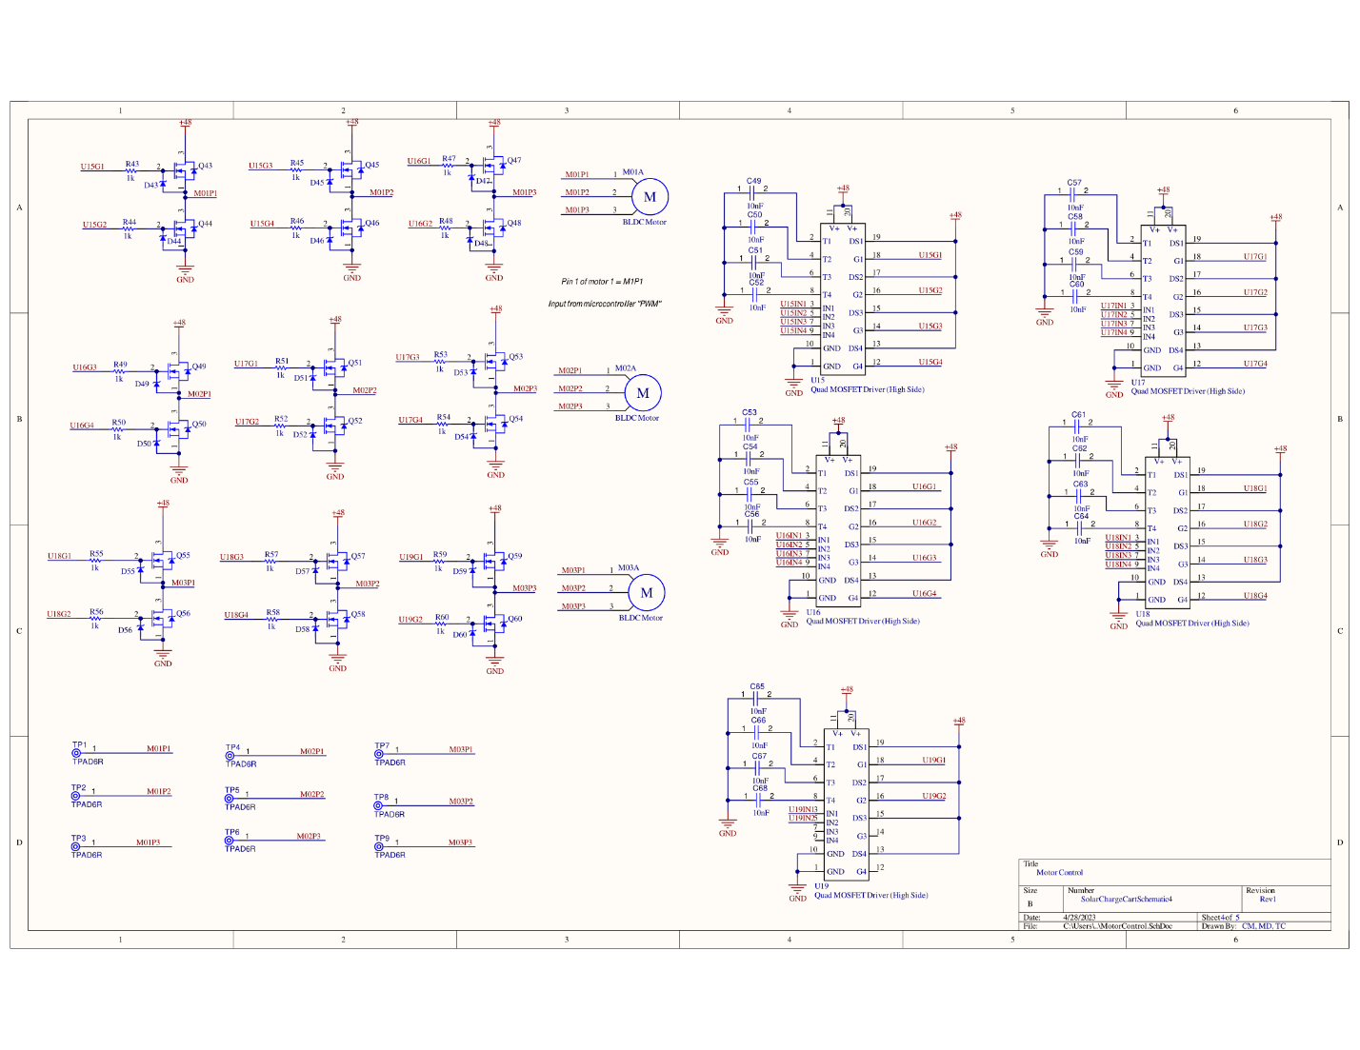

Figure 20. Motor control schematic sheet (4 of 5)

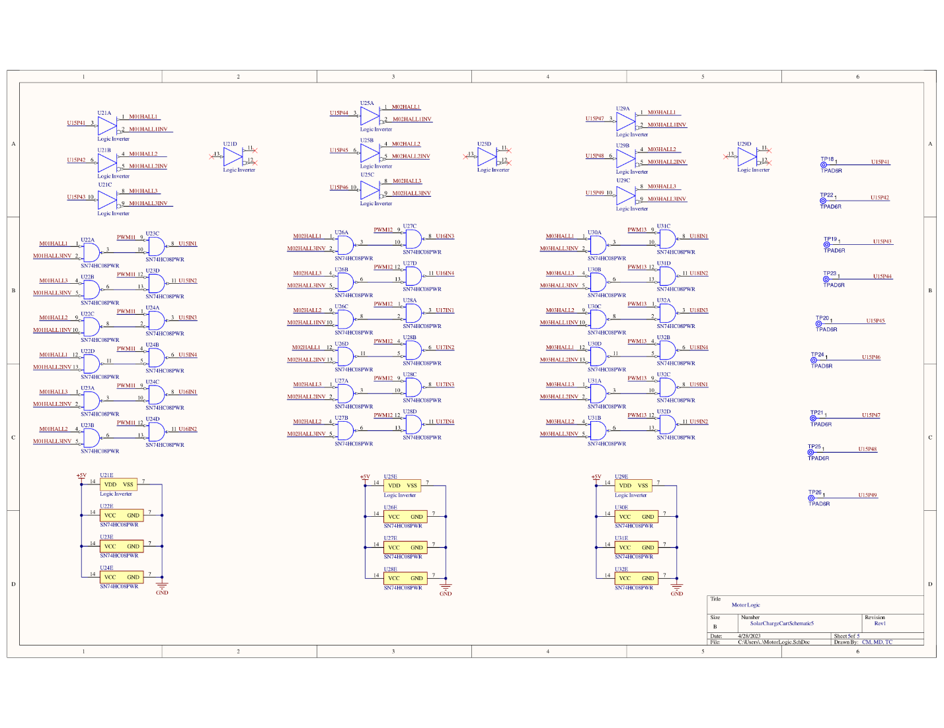

Figure 21. Motor logic schematic sheet (5 of 5)

*Figure 17* and *Figure 18* of the electrical schematics show the two battery arrays that each connect four of the five total batteries to the main power bus, producing the necessary 48 V. In order to remove the battery for charging, the battery requires a MOSFET on either side of it, a MOSFET to go around it, and two MOSFETs that can connect it to the solar panel charging system. While some MOSFETs can be reused to switch multiple batteries, the decision to charge the batteries while running the device adds complexity to the design and adds 5 MOSFETs for each array.

To charge a battery, the MOSFETs on either end of it must be turned off, removing it from the other batteries in series. Then, the MOSFET that goes around the charging battery can activate at the same time as the MOSFETs that connect the charging battery to the solar panel. This is possible because the battery is already disconnected from the rest of the circuit, so there should not be any undesired outcomes with the MOSFETs being activated at the same time.

Any MOSFET used for high power application cannot rely on a normal logic output to power the high current and voltage the device needs to switch. A gate driver IC is used to supply the MOSFETs with the proper voltage and current and can be seen to the left of the battery array circuit.

The MOSFETs being used are N-Channel, which means considerations must be made for the placement of the MOSFETs relative to ground. If a MOSFET is placed with the source connected to ground, a voltage to the gate above the threshold voltage will turn the MOSFET on. If the MOSFET is placed with its source above ground, the gate must be at the threshold voltage plus the source voltage. This means the MOSFETs in the battery array may not be at ground and may not even be at the same voltage depending on which battery is being charged. Because of this, the selected gate driver must allow for high-side or floating configuration, which senses the source voltage and allows the gate to be at a certain level above this voltage. The chosen gate driver can supply voltages 15 V above the supply voltage and can be used at any voltage level up to the supply voltage [50]. This creates a high voltage being supplied to the MOSFETs despite the voltage of the MOSFET, which introduces a problem. A MOSFET tied to ground would be turned on with about 60 V, which is enough to damage the MOSFET. This problem is solved according to the datasheet for the driver by placing a 15V Zener diode from the gate to the source [50], which would clamp the gate to 15V when it is turned on. There is a resistor placed in series with the MOSFET gate, which limits the current in the gate of the MOSFET. The driver already has a current limit [50], but if that limit is undesired for any reason, the resistor can be adjusted to allow for more control over the gate current. The driver also has an overcurrent configuration [50] which is not being used, so the inputs corresponding with the overcurrent circuit are tied to ground with a capacitor. This is done so that the overcurrent would not permanently disable the output if the overcurrent were to accidentally trigger.

*Figure 19* of the schematic shows the power management and control circuitry, which shows how the solar panels, microcontrollers, and other power supplying devices interact with each other. On the left there is an Arduino Mega, which interfaces with the motor position sensors as an analog input, which can convert the hall sensor signal into a digital logic signal. The Mega also takes the steering signal, the brake, and the accelerator as an input, outputs the PWM signals for each motor, and outputs the motor position signals. A commercial solar charge controller (Victron Energy BlueSolar MPPT 100/30) will be used to interface the solar arrays to the batteries for recharging. The reason why this solar charge controller has been selected is due to its serial communication capabilities over a proprietary protocol (VE.Direct) which resembles the CANBUS serial communication protocol typically used in automotive electronics applications [51]. The next steps for the team will be to develop an interface and software routine to handle the serial communication with the solar charge controller so that the battery recharging and MPPT features of the solar charge controller can be adjusted when each battery is switched out of the battery array.

In the center of the page are two Arduino Nanos, and each one determines which MOSFETs are active for the battery management circuit described earlier. The output of each Arduino nano is 11 digital signals that is enough to properly configure the batteries to charge properly.

The right side of the page depicts the solar panel circuitry, which is two solar panels in parallel, both of which in parallel with a solar charge controller that can find the maximum power that can be extracted from the panels. The output from the panels is then placed in parallel with a large capacitor that smooths the output voltage. Below is the 5 V power supply that is used to power the microcontrollers, which takes a 48 V input and outputs a 5 V output. Each rail has a capacitor that can smooth the output voltage, which is especially necessary when considering the switching nature of the voltage converter. At the bottom of the page are the accelerator, brake, and the steering sensor, which are connected to the Arduino mega to control the motor speeds.

*Figure 20* of the schematic shows the motor control circuitry which consists of three motors, each with three poles and two MOSFETs per pole. This can be seen in the top left corner. For each pole, either the top MOSFET can be turned on, or the bottom MOSFET can be turned on. If the top MOSFET is turned on, 48 V is applied to the pole and current will flow into the pole. If the bottom MOSFET is turned on, ground is applied to the pole, and current will flow out of the pole. The poles that are supposed to be on and off are determined by the position of the motor, which is described on the next page of the schematic.

*Figure 21* of the schematic shows the motor logic, which takes 3 inputs from the motor position, and creates 6 outputs, one for each MOSFET that can control a motor pole. The logic is determined from [52], which graphs the motor position vs the motor poles, and is used to solve the resulting logic circuit. The motor position sensor is inverted, allowing the position and its inversion to be present at any point, which makes the resulting logic much easier. The sum of minterms is then produced and is ANDed with the PWM signal from the microcontroller. This is the final signal that can be sent to the motor MOSFETs and power the motor.

## ***Software Flow Charts***

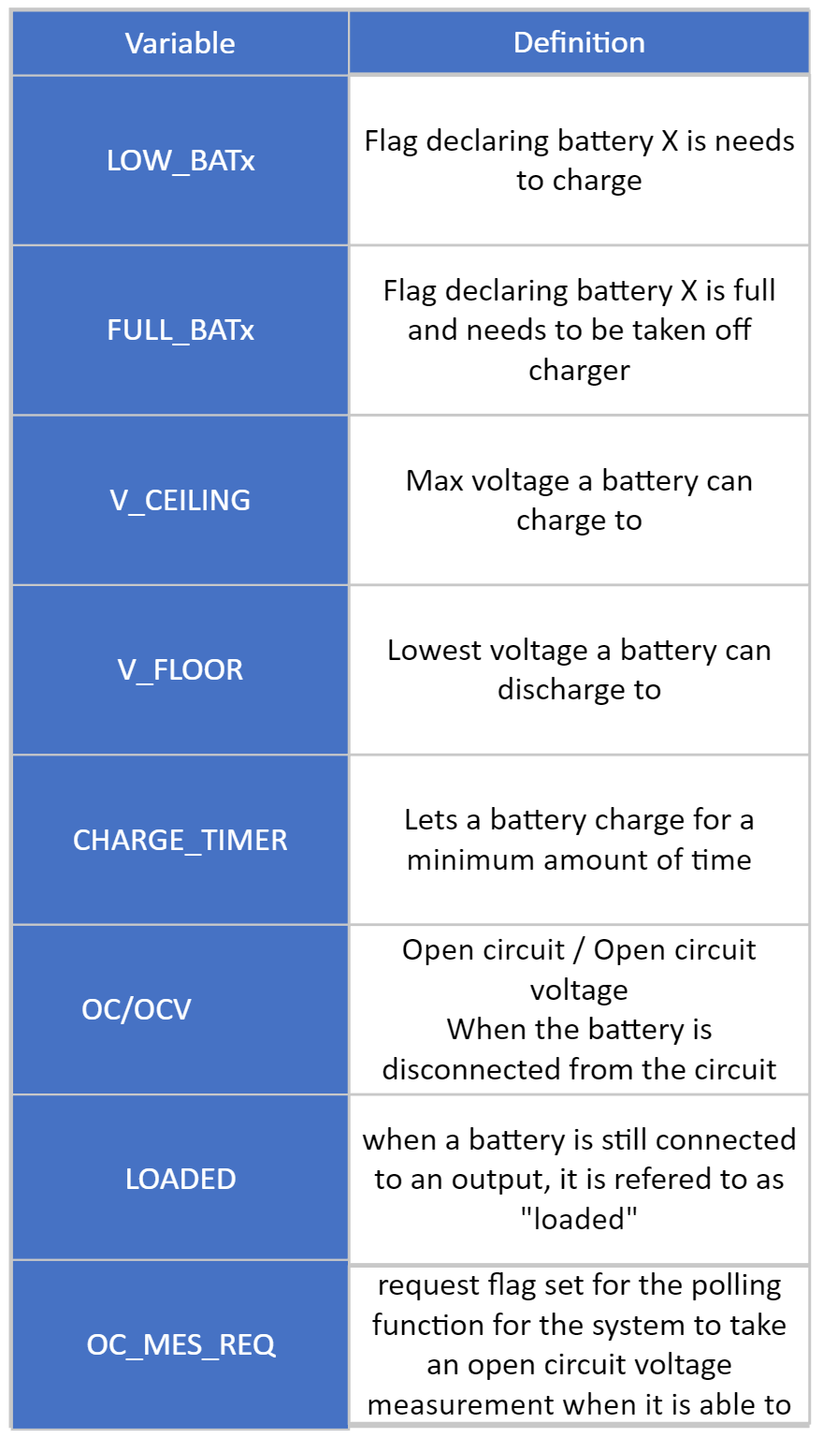

Figure 22. Variable definitions for battery charge control flowcharts

*Figure 22* shows the variables that will be used throughout the system’s battery charge control program. LOW_BATT is a flag that is raised when a battery reaches too low of a terminal voltage. The value of LOW_BATT will be the battery that is too low. This way, the value of LOW_BATT can be used in a switch statement to activate one of the charge configurations seen in *Figure 23*. FULL_BATT is a flag that will be used to signify a battery is fully charged. The value of this flag would be 1 or 0 and it would be the conditional for an if/else statement. The code does not need to know what battery was full, only which battery was the lowest in the array at the time the FULL_BATT flag was raised. The if/else statement would be used to call a function that would set the LOW_BATT flag previously discussed to the battery that was low in the array. V_CEILING and V_FLOOR will be used to describe the upper and lower limits of the battery voltages.

Figure 23. MOSFET configurations table

The MOSFET configurations table in *Figure 23* shows the separation between charging and output FETs, as well as which combination is engaged to charge a specific battery. For example, configuration 0 has all FETs disconnected, so there is no output and no charging. Whereas in condition 2, charging FETs 3 and 4 are connected to the battery terminals, charging the battery, and output FETs 11, 14, 16, 19 and 21 are engaged, connecting batteries 1, 2, 4, and 5 in series with each other, to make the needed 48 V.

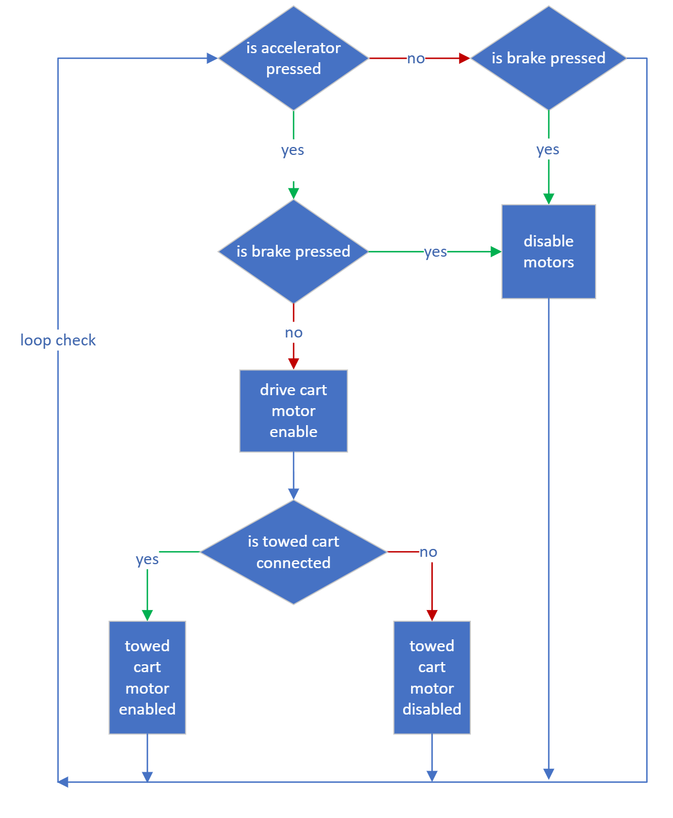

Figure 24. Accelerator control flow diagram

The accelerator flow diagram above in *Figure 24* shows how motor control will be performed on the software level. The code will be a loop continuously checking if the accelerator or the brake is pressed. If the accelerator is engaged, the driving carts motors as well as the towed cart, if one is connected, will be engaged. However, if the brake is pressed in any case, the motors will be disabled. This will be done to protect the motors from burning themselves out.

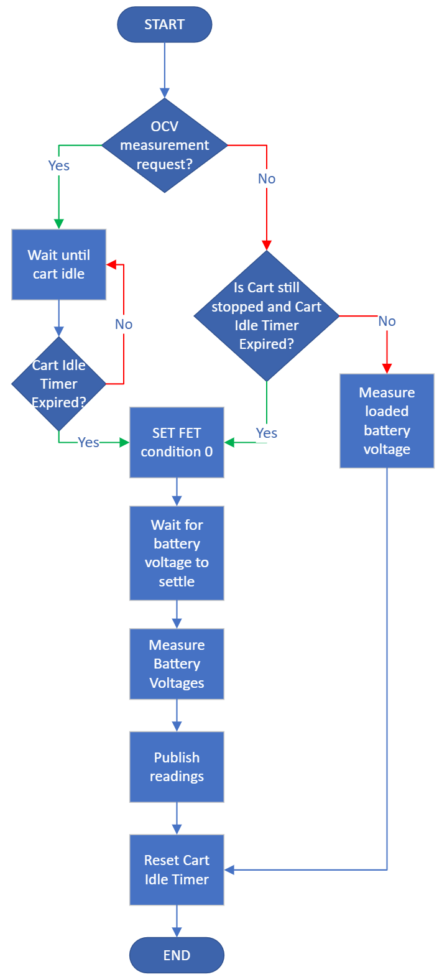

Figure 25. Battery voltage measurement flow diagram

To check the battery voltage, a series of other checks must be performed. Firstly, the program will check if an open circuit voltage measurement request has been made. If it is, the system will wait until the cart has been stopped for a predetermined time interval, then set the FETs to configuration 0, disconnected them all. Once the FETs have been disconnected, the system will wait for the voltage to rest before polling the data. This battery voltage measurement routine is outlined above in *Figure 25.*

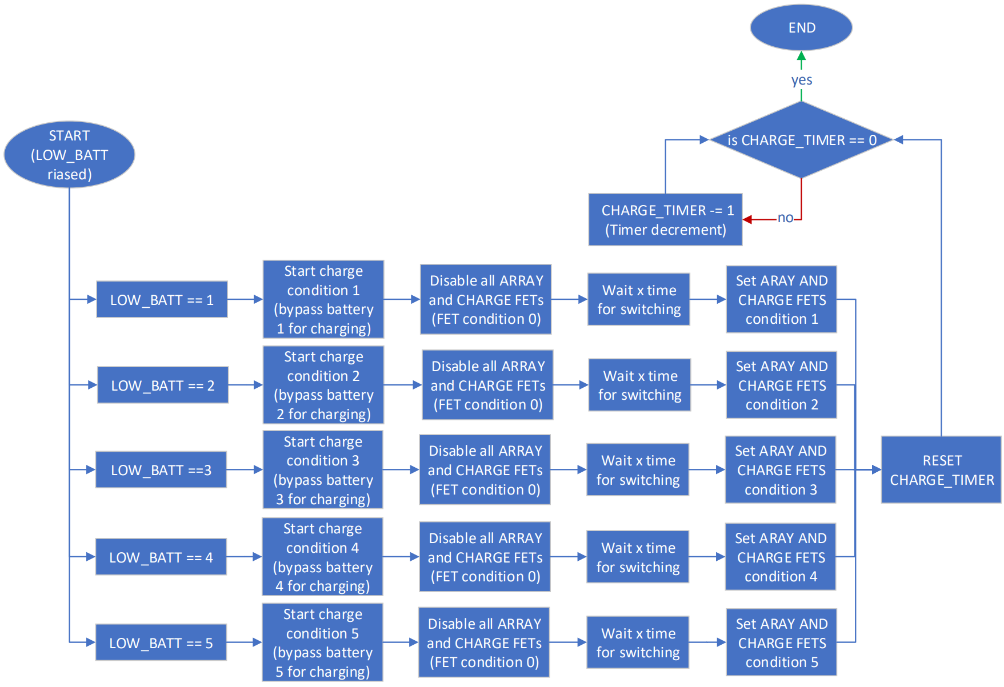

Figure 26. LOW_BATT flag handling flow diagram

For the batteries to charge, they must be disconnected from the array’s output. To do this, the batteries have a series of FETs to switch them in and out of the output array. However, when switching between the different MOSFET configurations, there needs to be a slight delay to allow any charge to dissipate before reconnecting with to the system. This can be seen in *Figure 26* as the modes are changed.

## ***Disclosure of non-original design content***

The vehicle chassis will be built upon a provided frame constructed by high school students under the direction of Professor Mil’shtein for a solar powered riding lawn mower. The provided frame contents are shown in *Figure 27* below.

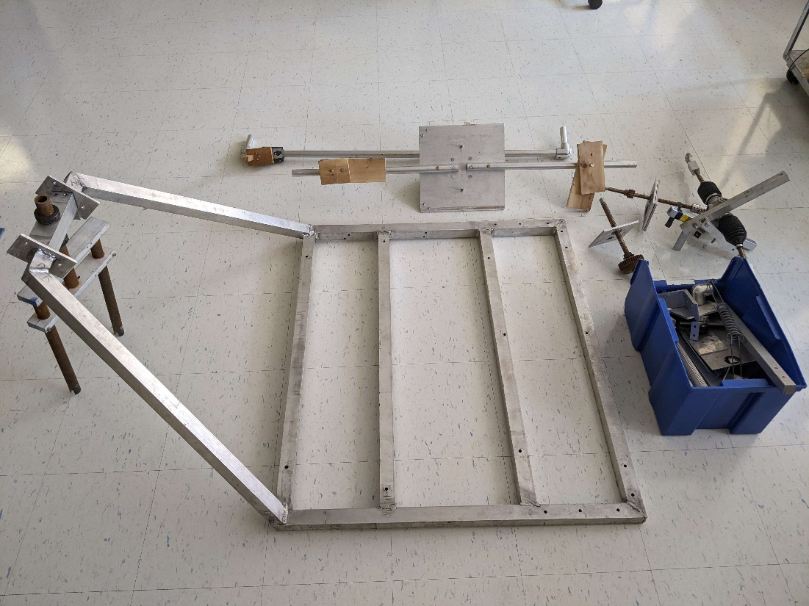

Figure 27. Provided vehicle chassis parts (from Professor Samson Mil’shtein) [53]

Figure 28. Electrical circuitry block diagram for existing solar-powered lawnmower

*Figure 28* describes the basic block diagram for the electrical components of the system. Professor Mil’shtein provided this from a solar-powered lawn mower project which he had previously overseen. The only aspect of this diagram that does not transfer over to this project is the blades actuator, which was used to drive the electric motor that spun the cutting blade of the mower. Otherwise, the diagram accurately describes this project’s electrical diagram.

Lastly, a commercial MPPT solar charge controller (Victron Energy BlueSolar MPPT 100/30) will be utilized to assist with interfacing the solar PV array with the battery system [51]. Since such a controller will not be designed from scratch, credit for its design cannot be assumed by the team.

The electrical schematic has several non-original design components, the most important being the motor-control circuitry. An article on BLDC motor control [52] was used to supplement the design of the circuit, which gave a schematic of a typical bridge for a brushless motor and a table for when each MOSFET would be activated.

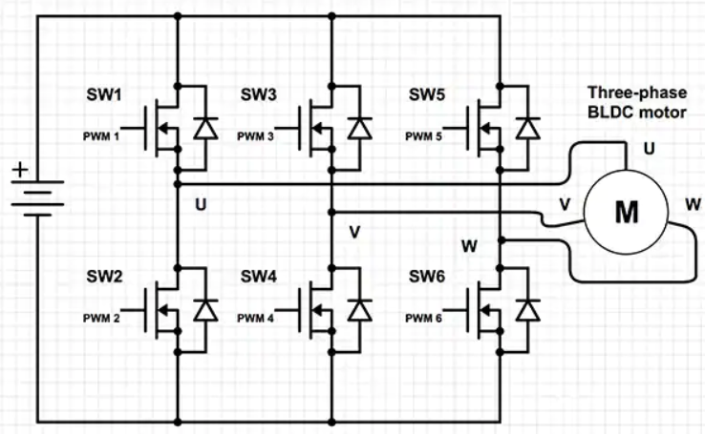

Figure 29. Typical configuration of a brushless DC motor [52].

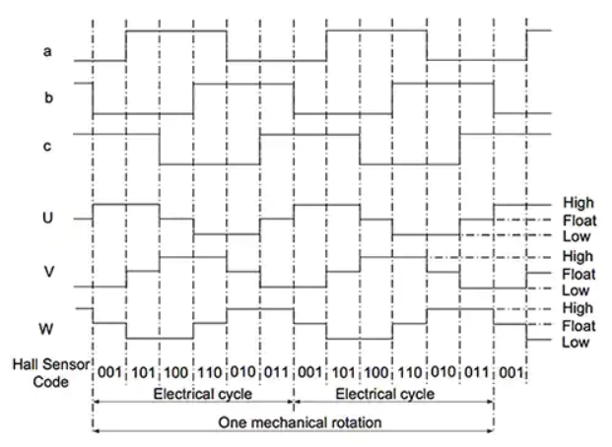

Figure 30. Brushless motor pole polarity as a function of the motor position [52].

*Figure 29* shows a configuration for the brushless motor that would allow the motor to spin freely with the correct logical signals [52]. The two MOSFETs per pole allow each pole to either be positive when the top MOSFET is active, or negative when the bottom MOSFET is active. The motor can also be floating if both MOSFETs are turned off, which is used to smooth the motor rotation further [52]. The proper logic to rotate the motor can be determined from *Figure 30*, which shows the three motor poles and how they should be energized. By determining all the possible sensor output combinations, the logic output for each MOSFET can be calculated by simplifying the different states. This calculation is performed by the team, but the initial assumptions for the sensors and the pole polarity is supplemented with [52].

Another source of non-original design is the MOSFET driver wiring, which is due to the differences between every IC that can be used. The selected chip is a quad driver that decreases the required number of drivers to only about a quarter of the required MOSFETs. The driver contains 4 logical inputs that can be wired directly to a microcontroller, and 4 gate pins that can connect directly to a MOSFET gate. The chip contains a current limiting circuit and has overcurrent protection that is configured with the DS pins and the T1 pins. The DS pins sense a current through a resistor and triggers the output to shut off when the voltage drops below a certain point. This is not used, so the DS pins are connected directly to the power source and should not drop below the threshold. The circuit also requires capacitors to be placed on the T pins which creates an RC timer to reset the overcurrent protection [50]. Since it is not being used, the capacitor size does not matter, but the capacitor should be placed so if the overcurrent triggers for some reason the circuit can be reset. The datasheet for the IC also describes how to use the chip as a low side driver and requires a Zener diode to limit the voltage of the gate to 15 V above the source.

## ***Bill of Materials***

*Table 6* shows a preliminary bill of materials for the electrical assembly and exists to guide the part selection that will occur in the future. The types of components are listed with the description of the components, the reference designator of the part in the schematic, and the quantity of each component.

Table 6. Preliminary electrical bill of materials

|  |  |  |  |
| --- | --- | --- | --- |
| Title | Description | Reference Designator | Quantity |
| Battery | 12 V 200 AHr | BT01-BT10 | 10 |
| Capacitor | 10 nF | C01-C71 | 71 |
| Zener Diode | 15 V Zener | D01-D60 | 60 |
| Motor | 8 kW | M01-M03 | 3 |
| MOSFET | 260 A, 48 V | Q01-Q11, Q22-Q32, Q43-Q60 | 40 |
| MOSFET | 20 A, 48 V | Q12-Q21, Q33-Q42 | 20 |
| Resistor | 1 kΩ | R01-R60 | 60 |
| SPDT Switch | Main power switch | S01 | 1 |
| Solar Panel | 24 V, 200 W | SP1, SP2 | 2 |
| Mechanical Switch | Accelerator | SW01 | 1 |
| Mechanical Switch | Brake | SW02 | 1 |
| Mechanical Switch | Steering | SW03 | 1 |
| MOSFET Gate Driver | Linear Technology LT1161 | U1-U6, U8-U13, U15-U19 | 17 |
| Microcontroller | Arduino Nano | U7, U14 | 2 |
| Microcontroller | Arduino Mega | U20 | 1 |
| Logic Inverter | TI-CD4041UB | U21, U25, U29 | 3 |
| Logic AND | 4CH 2-INP 14TSSOP | U22-U24, U26-U28, U30-U32 | 9 |
| 5 V Switching Regulator | DJ06S4805A | U33 | 1 |
| Solar Charge Controller | Victron Energy BlueSolar MPPT 100/30 | U34 | 1 |

* 1. ***Interfaces***

The interfaces for this vehicle must be specified due to both design considerations and user compatibility. As in any vehicle, this cart has a steering wheel, accelerator, and brake for the driver to immediately interact with. The driver of the vehicle will step on the brake and accelerator with their foot and follow normal road etiquette. The steering wheel – turned with the driver’s hands, will be operated through mechanical means. It will turn the wheels of the cart (rear two-wheel drive) and allow the driver to direct the cart in their desired direction, as safely and accurately as possible. The accelerator will allow the user to speed up the cart to the specified maximum limit, with acceleration designed to be a smooth and consistent process. The brake pedal will initiate the deceleration of the cart over a small distance before bringing it to a complete, controlled stop. Additionally, for outward interfaces, the driver will refer to the charge indicator of the batteries as well as the speedometer. The speedometer will record the speed that the cart is traveling at, and the user will frequently refer to it to stay within a desired luggage cart speed. The charge indicator will show when the cart needs to stop and shutdown so that the solar panels can charge the batteries. The user will frequently refer to this to optimize time usage of the vehicle in reference to when it needs to charge and for how long it can run. The next step for the team is to implement these interfaces into the existing electrical schematics and mechanical drawings.

# ***Project Reflection***

## ***Cost estimate (Proof-of-Concept)***

*Table 7* below outlines the estimated average cost for each electrical and mechanical subsystem for the solar-powered luggage cart, in addition to the anticipated quantities required for each. Three hub motors will be purchased to accommodate one driving vehicle that is 2-wheel drive and one luggage cart equipped with a singular hub motor. Four solar panels, each at 12 V, 200 W, will be purchased and connected in series to provide a 48 V input to the solar charge controller. Implementation of a 48 V solar PV array will reduce the losses of converting a lower solar PV array voltage (12 V or 24 V) to the required 48 V system voltage. Similarly, four 12 V batteries must be placed in series to achieve the desired system voltage of 48 V, and the series-connected batteries must be connected in parallel to achieve the desired capacity of 600 Ah. Thus, 16 batteries each rated at 12 V and 200 Ah must be purchased. A singular solar charge controller which can interface the selected 48 V AGM battery system with the 48 V solar PV array using MPPT must therefore be purchased. Aluminum will be used to construct the frame for the driving vehicle and the luggage cart due to its lightweight properties, structural rigidity, and relatively cheap cost. According to [59], T-slotted framing (which are hollow or solid beams/bars made of aluminum or other similar metals that can be used for a wide variety of framing/construction purposes) is sold per-unit length. Longer lengths of T-slotted frames have a lower cost-per-unit length than shorter lengths, so the purchase of longer lengths and cutting down to size may help to reduce costs. As an estimate, 50 ft of aluminum framing will be required to construct the frame for both the driving vehicle and the luggage cart, but this will be adjusted once the dimensions for the vehicle sections have been finalized.

Table 7. Cost estimate for the required components

|  |  |  |  |  |
| --- | --- | --- | --- | --- |
| **Major Sub-System Components** | **Description** | **Quantity** | **Cost (Average according to research)** | **Subtotal Cost** |
| Hub Motors | 48 V, BLDC, Permanent Magnet | 3 | $1500 each [54] [55] [56] | $4500 |
| Solar Panels | 200 W, 12 V, Flexible, Monocrystalline | 4 | $326 each [57] | $1304 |
| Batteries | 12 V, 200 Ah, Deep Cycle, AGM | 16 | $360 each [58] | $5760 |
| Solar Charge Controller (off-the-shelf) | MPPT, 48 V AGM-compatible, | 1 | $350 [59] [60] [61] | $350 |
| Aluminum Frame | T-Slotted Framing, 10ft sections | 5 | $45.88 [62] | $229.40 |
| **Total Estimated System Cost:** | | | | $12,143.40 |

According to *Table 7*, the estimated final system cost will be just over $12,000. Although this is a considerable cost, the team previously discussed with Professor Mil’shtein and Jeffrey Snell to determine that the system should not exceed a cost of $20,000. Intrinsically, the components with the quality and characteristics required to realize the design of this solar-powered luggage cart system, such as the hub motors and batteries, are expensive. Professor Mil’shtein advised the team that technology is not successful or useful if it is not profitable, so while this preliminary cost estimate is large, a balance between quality and project schedule is made. *Table 8* below provides an estimate of the amount of time required to complete each phase of the project.

Table 8. Estimated time for completion of each project phase

|  |  |
| --- | --- |
| **Design Phase** | **Estimated Completion Time (Hours)** |
| Project/Team Introductions | 12 |
| Research | 170 |
| Testing of Existing 500 W Solar-Powered Vehicle | Projected 160 |
| Initial Design (Mechanical/Electrical Schematics, System-Level Block Diagram) | Projected 72 |
| Initial Construction | Projected 170 |
| Testing/Redesign of Final System | Projected 500 |
| Report Write-ups and Team Meetings | 300 |
| **Estimated Total Project Completion Time:** | 1,384 |

The above time estimate may be subject to change depending upon the results of the design phase and the preliminary testing encouraged by Professor Mil’shtein for the existing 500 W hub-motor driven solar-powered vehicle. The reason for the uncertainty in this preliminary testing time is due to the team encountering several issues with trying to acquire suitable DC power supplies to power and test the available 500 W hub motors provided by Professor Mil’shtein. The intention with this testing is to acquire a better understanding of the power requirements and towing capabilities of the higher power final system.

1. ***Challenges and critical issues***

Some of the most difficult issues with this project were addressing the chassis construction as well as performing the initial calculations for torque, power, towing capacity etc. This was due to the fact that the team consists purely of electrical engineering students. Therefore, there was a learning curve to perform these calculations for the system. On top of this, the chassis the team received was completely disassembled and the design of another project of Dr. Mil’Shtein’s, adding complexity to how it should be reconstructed. These issues have called for an all-hands-on-deck approach from the team and as a result, the challenges have been slowly overcome and the team has learned from the experience.

The most difficult task for this project is to ensure the battery can supply power for an entire day indefinitely with only solar charging. Power management is necessary and great care must be taken in every part of the design to lower the electrical power the system consumes, especially when the vehicle is idling. Because of this, the system must be efficient as possible, as the efficiency of any component can be the difference between meeting this requirement or not.

The available power sources only allow for a maximum system voltage of 48 V, which makes the available torque for any driving wheels less than if they were powered by a higher voltage. This means the motor must be carefully selected to ensure the most torque can be provided at such a low voltage, and the system is more difficult to design around the motor.

This project is also higher power than the group has had academic experience with, and it will pose a challenge to work with currents over 100 A. Special consideration needs to be taken when it comes to external power supplies, wire gauge, testing equipment, and anything else that may carry a high current to ensure the team and vehicle operators are safe.

Challenges also come with motor suppliers, as some rated values are peak values, and some are average values. This means that two motors labeled 100 Nm may have different torques because of the way the supplier defines this nominal value. It sometimes is not well-defined which type of value is given, and 10 kW may not mean 10 kW. More time needs to be taken in these situations to ensure that a proper part is being selected, especially with long lead times.

This project also produces an electro-mechanical device, and as such the physical movement of the system needs to be considered. The project is undertaken by electrical engineers and mechanical dynamics is not a required course, causing the project to include more background research to understand these basic concepts of mechanical theory.

## ***Predelivery hazards/safety***



In terms of electrical hazards, the biggest potential hazard the team faces that will be experienced during testing of the system is the possibility of high current. The system produces a high current for running the motors and if not funneled properly this can prove dangerous as current is more dangerous than voltage. Additionally, there is a general hazard of electronics. There are going to be Printed Circuit Boards (PCBs) that are sharp and jagged, possess multiple electronic components, and most likely easily susceptible to shorting and electrical shock. If not handled properly, these can be damaged and damaging to the tester.

For mechanical hazards, there is the fact that this is a vehicle, and thus comes the hazards of a vehicle. The carts have a lot of momentum and weight and if control is lost, they can easily hurt someone. There is also the rotational hazard of the parts of the vehicle, the motors and wheels are spinning, which can also easily hurt someone. There is also the risk of the mechanical frame, made of metal parts, falling and hurting someone or damaging the system if not secured properly. The team will carefully consider the strength of the metal configuration as well as the tightness of the screws to maintain the integrity of the frame. There are also multiple heavy parts, wheels, motors, batteries, which are all at risk of hurting someone if not transported efficiently. The attached towed cart must also be safely attached to the driving cart, otherwise there is a risk of the towed cart disconnecting and possibly causing harm.

As for the hazards because of programming, if the control scheme is not handled properly there is a risk of the vehicle doing something undesirable. The brakes and the accelerator must act as intended and as the team tells them to act when they tell them to act. Any lapses in timing or accuracy can prove to be dangerous. Finally, the whole system possesses thermal risk. As this is a system with solar panels, batteries, motors, and PCBs, everything gets hot. If adequate heat sinks or safety precautions are not made then this system risks overheating, as any electronics always have a fire hazard due to the nature of electricity and materials.

## ***Hazards to end user***



External hazards to the operator and their environment include, it is a moving vehicle, there are multiple carts being towed at one time, and there are heavy, moving parts. Internal hazards include potentially hot components and high currents. The external hazards will pose a larger threat to the system’s environment as they will be most exposed. Ways to mitigate chances of injury would be to proper covers and labeling high-risk areas as well as informing the operator of parts of the vehicle that should be avoided. To lower operator’s potential harm when performing maintenance inside of the vehicle, proper labeling and covers on high-risk areas as well as being properly trained on the internal systems and maintenance procedures.

## ***Standards Utilized***

*Standards List 1: Standards Applicable to Component Suppliers*

1. **EN/IEC 62109-1: Safety of power converters for use in photovoltaic power systems [63]**

Standard EN/IEC 62109-1 [63] specifies requirements and test procedures pertaining to the potential safety hazards of power conversion equipment (PCE). PCE includes a broad variety of circuit topologies which are used to convert between different forms of electrical energy, such as DC/DC converters (which convert a DC voltage of one level at the input to either a higher or lower DC voltage at the output) or solar AC inverters (which convert the DC voltage/current output of solar panels to an AC voltage/current replicating the mains/power grid). One candidate Maximum Power Point Tracking (MPPT) solar charge controller by Victron Energy [64] lists EN/IEC 62109-1 as one of the standards with which it is compliant. Since such solar charge controllers are typically installed in residential applications, ensuring that the device poses no electric shock hazard to the installer or homeowner is critical. Further, the mechanical and environmental requirements from the standard ensure the device to withstand varying conditions which it might encounter after or during installation (such as exposure to fluids from either internal components or external sources, impact of the device on pollution, and the resilience of the device to varying temperatures and humidities).

In terms of how EN/IEC 62109-1 applies to the solar-powered luggage cart, the requirements on safety (mostly pertaining to electrical, mechanical, and environmental hazards) will be most beneficial. Although the project is a proof-of-concept of a larger scale luggage transport vehicle, the considerations about electric shock hazards (with large currents being drawn from the battery to power the hub motors) and mechanical hazards from moving parts (which comprises mainly of the wheels/hub motors) is crucial to ensuring the safety of the design team and client.

1. **IEEE 1562-2007: IEEE Guide for Array and Battery Sizing in Stand-Alone Photovoltaic (PV) Systems [65]**

This IEEE standard provides guidelines, not strict requirements, for properly sizing PV solar arrays and battery systems for off-grid (or stand-alone) photovoltaic systems. Specifically, the standard focuses on multiple PV array chemistries intended to interface with only lead-acid batteries, citing irradiance and environmental conditions from the worst-case month (likely in Winter) according to the “Sun-hour” PV array sizing method. In addition to a comparison of different PV array chemistries, the standard provides information about different solar charge controller technologies (including MPPT), which is beneficial to choosing the best combination of PV array and battery for the final system. Important to note is that this standard is a guideline provided by a professional organization (IEEE), not a mandated set of requirements from a government agency or regulatory body. So, while most solar PV arrays and batteries might not strictly follow these guidelines, they are still applicable to these components which are used in the solar-powered luggage cart.

1. **IEC 60529: IP Ratings [66]**

This standard sets the categories for the IP rating system, which determines how well a product can withstand solid foreign objects and water. The rating system has two digits, the first corresponding to the level of resistance against solid foreign objects (dust) entering the system, and the second corresponding to the level of resistance against water entering the system. The first digit can be 0-6, ranging from no protection from dust to dust-tight, and the second digit can be 0-9, ranging from no protection to high temperature and high-pressure protection.

The project must be able to withstand the normal weather conditions of the area, and rain and dust will occur. All components of the project that are not in a weatherproof enclosure would have to be rated for the proper level of resistance against rain and dust. The most applicable components are the solar panels and the batteries, which must have some form of resistance.

*Standards List 2: Standards Required for Hypothetical Production and Manufacture*

1. **IEC61000-4-2/3/6/etc. Electromagnetic Interference and Susceptibility Testing [67] [68]**

This standard covers a wide range of tests that need to be performed on all electronic devices that are to be sold to industrial and commercial markets. Some tests consist of conduction and radiated emissions of electromagnetic fields (RF) and electrostatic discharge. The RF tests the system will not cause interference with radio-waves, or have faults caused by said waves. The tests run on a logarithmic scale of frequencies ranging from kilohertz to gigahertz, and the emissions of the system being tested must be below a specified decibel level for the given frequency.

The ESD testing is to ensure that the system will not faulter during an ESD event. Many devices are static sensitive, and as people naturally develop a static charge on them, interacting with said devices could cause damage if not properly protected. The tests run from 2 kV to 8 kV with contact, and air discharges.

1. **IEEE 937-2019 Recommended Practice for Installation and Maintenance of Lead-Acid Batteries for Photovoltaic (PV) Systems [69]**

This standard discusses design considerations and procedures for the usage of lead-acid batteries in Photovoltaic (PV) systems. The standard discusses how lead-acid batteries should be installed, stored, maintained, and removed in industrial, residential, and commercial PV systems. The standard was designed by the Energy Storage and Stationary Battery Committee, which oversees the regulation of many different types of batteries.

If this project were to be produced with the purpose of selling, this standard would need to be followed, because all electronic components must follow IEEE regulations. This standard provides the best methods and procedures for ensuring that the batteries used in the PV system are tested for safety and quality for it to be valid for commercial uses.

1. **FAA AC 150/5210-5D Painting, Marking, and Lighting of Vehicles Used on an Airport [70]**

This standard gives recommendations for how vehicles in airports should be painted. The standard is mandatory for any ground vehicle that is paid for with government funding and is recommended for all vehicles. The section specific to luggage carts states that they can be painted any color other than yellowish green or yellow and the bumper of the cart must be painted with alternating yellow and black. The cart’s roof and side must be painted with an identification number that meets certain size requirements and must be painted a color contrasting the color of the vehicle. The vehicle must have a reflective stripe and a flashing yellow light to increase visibility.

If this project were being produced to be sold, it would need to follow the FAA regulations and this standard would likely be followed for the cart. While it is not required unless the vehicle is bought with government money, this standard provides the safest way to paint a ground service vehicle for an airport. Producing a vehicle that matches this standard allows for the vehicle to be used in any airport that meets the FAA standards.

# **Summary**

The project goal is to design and build a battery-powered vehicle that has the capability to tow a load of up to 1200 kg and is recharged using solar panels. The end goal of the project is to provide research in the field of small-scale, zero-emissions, load-hauling vehicles with a primary focus on luggage transportation vehicles for airports. Ideally, the project will result in a product that can be patented by the students, along with a technical paper to publish, giving the students an accomplishment that they can add to their resumes. This report discusses the overview of the project, including what the reasoning is to create a solar-powered vehicle, and a statement of the problem and objective of the project. The report includes information on the project mentor, Dr. Samson Mil’shtein, a Professor Emeritus at the University of Massachusetts Lowell, and contains research on previous luggage cart designs, mechanical theory, battery systems, photovoltaic power, motor theory, and power circuitry, all of which giving background that the selected design can be based off. The requirements that the system must fulfill are determined, guiding the design and testing phases of the project. A comparison of different solutions was made, and each aspect of the project was inspected. A preliminary electrical and mechanical block diagram was created, and the most appropriate solution was decided.

The immediate task is to finish testing an existing solar-powered prototype vehicle based on 500 W hub motors to get an idea of how the final product should function. Concurrently, the team will complete the part selection process and order the necessary parts. Required revisions will be made on the mechanical drawings and the electrical schematics, and this process will be repeated until the cart is complete. The cart will then be tested to ensure it meets the requirements and a final report will be written containing any information produced after this point.

# **References (IEEE)**

[1] A. Desreveaux, A. Bouscayrol, R. Trigui, E. Hittinger, E. Castex, G.M. Sirbu, " Accurate energy consumption for comparison of climate change impact of thermal and electric vehicles," *Energy*, vol. 268, April 2023, doi: 10.1016/j.energy.2023.126637 [Accessed: 04-Mar-2023].

[2] “Advanced Electronic Technology Center,” *UMass Lowell*. [Online]. Available: https://www.uml.edu/research/aetc/. [Accessed: 04-Mar-2023].

[3] “Samson Mil'Shtein: Electrical & Computer Engineering: Francis College of Engineering,” *Electrical & Computer Engineering | Francis College of Engineering | UMass Lowell*. [Online]. Available: https://www.uml.edu/engineering/electrical-computer/faculty/milshtein-samson.aspx. [Accessed: 04-Mar-2023].

[4] Wilcox Ground Services, “Wilcox Ground Services Closed Baggage Cart,*”* data sheet, July 2022 [Online]. Available: https://wilcoxgroundservices.com/wp-content/uploads/2022/07/Baggage-Carts-Wilcox-GSE.pdf. [Accessed: 03-Mar-2023].

[5] Alkè, “ATX Range Technical Data,” BN17607/17303 datasheet, 2018 [Revised April 18, 2022] [Online]. Available: https://www.alke.com/doc/alke-atx-electric-vehicles-catalog-eng.pdf. [Accessed: 03-Mar-2023].

[6] Waev inc, “Tiger Lithium-Ion Tow Tractors,” *Tiger Lithium-Ion tow Tractors*, 07-Apr-2022. [Online]. Available: https://brandfolder.com/s/x2gp25n6tphn3ggm9cw96. [Accessed: 04-Mar-2023].

[7] “2021 brand new electric tow tractor with capacity 5TON electric platform truck,” *2021 Brand New Electric Tow Tractor With Capacity 5ton Electric Platform Truck - Buy Tow Tractor,Electric Tow Tractor,Electric Platform Truck Product on Alibaba.com*. [Online]. Available: https://www.alibaba.com/product-detail/Electric-Tow-Tractor-2021-Brand-New_1600343530459.html?s=p. [Accessed: 22-Mar-2023].

[8] “Electric three wheels battery seated tow electric truck tow tractor new,” *Electric Three Wheels Battery Seated Tow Electric Truck Tow Tractor New - Buy Airport Baggage Towing Tractor,Airport Tow Tractor,Electric Tow Tractor Product on Alibaba.com*. [Online]. Available: https://www.alibaba.com/product-detail/Electric-3-Wheels-Battery-Seated-Tow_1600691837435.html?s=p. [Accessed: 22-Mar-2023].

[9] Womack, “Force required to accelerate a load,” 1988. [Online]. Available: https://www.womackmachine.com/engineering-toolbox/data-sheets/force-required-to-accelerate-a-load/. [Accessed: 03-Mar-2023].

[10] M. N. Kumar, V. Jagota, and M. Shabaz, “Retrospection of the Optimization Model for Designing the Power Train of a Formula Student Race Car,” *Scientific Programming*, vol. 2021, no. 9465702, pp. 1–9, Nov. 2021, doi: https://doi.org/10.1155/2021/9465702.

[11] G. Lechner and H. Naunheimer, *Automotive Transmissions: Fundamentals, Selection,*  *Design and Application*. Springer Science & Business Media, 1999. Accessed: Mar. 01, 2023. [Online]. Available: https://books.google.com/bookshl=en&lr=&id=vEKbhuFVh JEC&oi=fnd&pg=PR17&dq=car+power+losses+in+transmissions&ots=abY_WidyU q&sig=q4RZ67_eN60HGYMkKxV0ZatNRRI#v=onepage&q&f=false.

[12] S. J. Chapman, “Electric Machinery Fundamentals.” New York, NY: McGraw-Hill, 2012, pp. 464-526 ;606-610. [Accessed: February 28, 2023].

[13] S. Bakker. “Tesla Model 3 Motor – Everything I’ve Been Able To Learn About It.” cleantechnica.com. [Online]. Available: https://cleantechnica.com/2018/03/11/tesla- model-3-motor-in-depth/. [Accessed: February 28, 2023].

[14] J. Banner. “No Magnets, Big Power: BMW’s Fifth-Generation Electric Motor.” motortrend.com. [Online]. Available: https://www.motortrend.com/news/bmw-ix-m60- brushed-electric-motor-tech-deep-dive/ . [Accessed: February 28, 2023].

[15] Club Car. “Villager 6” clubcar.com. [Online]. Available:https://build.clubcar.com/build/ villager-6-electric?_ga=2.94604058.700344813.16776020451774749036. 1677602045&_gl=1%2A1eak825%2A_ ga%2AMTc3N Dc0OTA zNi4xNjc3NjAyMDQ1%2A_ga_W1LNP8Q2Z2%2AMTY3NzYwMjA0 NS4xLjAu MTY3NzYwMjA0NS42MC4wLjA.&task=4x2 . [Accessed: February 28, 2023].

[16] Yamaha. “Build Your Own Car.” yamahagolfcar.com. [Online]. Available: https://www.yamahagolfcar.com/buildyourowncar/. [Accessed: February 28, 2023].

[17] Club Car. “Transporter 4 Passenger” clubcar.com. [Online]. Available: https://build.clubcar.com/build/transporter-4-electric_ga=2.94604058.700344813 . 1677602045-1774749036.1677602045&_gl=1*1eak825*_ga* MTc3NDc0O TAzNi4xN jc3NjAyMDQ1*_ga_W1LNP8Q2Z2*MTY3NzYwMjA0NS4xLjAuMTY3NzYwM jA0NS42MC4wLjA.&task=4x2 . [Accessed: February 28, 2023].



[18] P. Yedamale, “Brushless DC (BLDC) Motor Fundamentals.” Microchip [Online]. Available:http://electrathonoftampabay.org/www/Documents/Motors /Brushless%20DC%20(BLDC)%20Motor%20Fundamentals.pdf . [Accessed: February 28, 2023].



[19] Y. -P. Yang and D. S. Chuang, "Optimal Design and Control of a Wheel Motor for Electric Passenger Cars," in *IEEE Transactions on Magnetics*, vol. 43, no. 1, pp. 51-61, Jan. 2007, doi: 10.1109/TMAG.2006.886153. [Accessed: February 28, 2023].

[20] C. Versèle, O. Deblecker, Z. De Grève and J. Lobry, "Multiobjective optimal design of a voltage supply inverter fed in-wheel synchronous motor," *2010 IEEE Vehicle Power and*  *Propulsion Conference*, Lille, France, 2010, pp. 1-6, doi: 10.1109/VPPC.2010.5729025. [Accessed: February 28, 2023].

[21] Elaphe. “Direct Drive In-Wheel Motors.” in-wheel.com. [Online]. Available: https://in- wheel.com/en/solutions-2/direct-drive-in-wheel-motors/ . [Accessed: February 28, 2023].

[22] Protean Electric. “Driving The Future Of Electric Vehicles.” proteanelectric.com. [Online]. Available: https://www.proteanelectric.com/. [Accessed: February 28, 2023].

[23] ORBIS Wheels. “ORBIS Wheel.” orbisdriven.com. [Online]. Available: https://orbisdriven.com/. [Accessed: February 28, 2023].

[24] *Renogy.com*, 2021. h<ttps://www.renogy.com/content/RNG-BATT-AGM12-2>00/AGM200- Datasheet.pdf (accessed Mar. 05, 2023).

[25] M. S and K. E, “Solar powered electric vehicle,” *IEEE Xplore*, Dec. 01, 2016. https://ieeexplore.ieee.org/abstract/document/7936074/. (accessed Jan. 23, 2023).

[26] S. Dhameja, *Electric Vehicle Battery Systems*. Elsevier, 2001. Accessed: Mar. 02, 2023. [Online]. Available: https://books.google.com/books? hl=en&lr=&id=fhNLk4afdz0C&oi=fnd&pg=PP1&dq=most+environmentally+friendly+ electric+car+battery&ots=kLYJJIH1PG&sig=KURdYaBz- FmDIjvp69usFY1TlP8#v=onepage&q&f=false.

[27] F. Trinidad, F. Sáez, and J. Valenciano, “High power valve regulated lead-acid batteries for new vehicle requirements,” *Journal of Power Sources*, vol. 95, no. 1–2, pp. 24–37, Mar. 2001, doi: <https://doi.org/10.1016/s0378-7753(00)00636-4>.



[28] C. Honsberg and S. Bowden, “Summary and Comparison of Battery Characteristics | PVEducation,” *www.pveducation.org*. https://www.pveducation.org/pvcdrom/battery- characteristics/summary-and-comparison-of-battery-characteristics. (accessed Mar. 01, 2023).

[29] S. Manzetti and F. Mariasiu, “Electric vehicle battery technologies: From present state to future systems,” *Renewable and Sustainable Energy Reviews*, vol. 51, pp. 1004–1012, Nov. 2015, doi: https://doi.org/10.1016/j.rser.2015.07.010.

[30] Y. Yu *et al.*, “Constructing Accurate Equivalent Electrical Circuit Models of Lithium Iron Phosphate and Lead–Acid Battery Cells for Solar Home System Applications,” *Energies*, vol. 11, no. 9, p. 2305, Sep. 2018, doi: https://doi.org/10.3390/en11092305.

[31] “RNG-175D 175W Monocrystalline Solar Panel.” Accessed: Mar. 05, 2023. [Online]. Available: https://www.renogy.com/content/RNG-175D/RNG-175D%20Datasheet.pdf

[32] M. Grosso, D. Lena, A. Bocca, A. Macii, and S. Rinaudo, “Energy-efficient battery charging in electric vehicles with solar panels,” *IEEE Xplore*, Sep. 01, 2016. https://ieeexplore.ieee.org/document/7740569. (accessed Mar. 01, 2023).

[33] J. Toothman and S. Aldous, “How Solar Cells Work,” *PBWorks*, 2000. http://wcpssccsi.pbworks.com/w/file/fetch/67747809/solar%20cells- 11162012150624.pdf. (accessed Mar. 02, 2023).

[34] M. Giannouli and P. Yianoulis, “Study on the incorporation of photovoltaic systems as an auxiliary power source for hybrid and electric vehicles,” *Solar Energy*, vol. 86, no. 1, pp. 441–451, Jan. 2012, doi: https://doi.org/10.1016/j.solener.2011.10.019.

[35] A. Shah, “Photovoltaic Technology: The Case for Thin-Film Solar Cells,” *Science*, vol. 285, no. 5428, pp. 692–698, Jul. 1999, doi: https://doi.org/10.1126/science.285.5428.692.

[36] J. Cubas, S. Pindado, and C. de Manuel, “Explicit Expressions for Solar Panel Equivalent Circuit Parameters Based on Analytical Formulation and the Lambert W-Function,” *Energies*, vol. 7, no. 7, pp. 4098–4115, Jun. 2014, doi: https://doi.org/10.3390/en7074098.

[37] P. K. Atri, P. S. Modi, and N. S. Gujar, “Comparison of Different MPPT Control Strategies for Solar Charge Controller,” *2020 International Conference on Power Electronics & IoT Applications in Renewable Energy and its Control (PARC)*, p. 2, Feb. 2020, Accessed: Mar. 02, 2023. [Online]. Available: https://ieeexplore.ieee.org/stamp/stamp.jsp?arnumber=9087178&casa_token=vQs6e9fSCG4AAAAA:ZZvIkwoPIC4OoXEd7jBmVfIFPzXpWKxlsXH0aFiKObymSmtwpROKwwIv_RsghdlgCWXlxp7vA&tag=1.

[38] T. Markvart and L. CastaÑer, “IIa-1 - Principles of Solar Cell Operation,” *Practical*  *Handbook of Photovoltaics*, p. 71, 2003, doi: https://doi.org/10.1016/B978-185617390- 2/50005-2.

[39] A. Hassan, O. Bass, and M. A. S. Masoum, “An improved genetic algorithm based fractional open circuit voltage MPPT for solar PV systems,” *Energy Reports*, vol. 9, pp. 1535–1548, Dec. 2023, doi: https://doi.org/10.1016/j.egyr.2022.12.088.

[40] M. Emanuel, “Implementing a Simple Maximum Power Point Tracking (MPPT) Algorithm,” Texas Instruments Incorporated, Dallas, Texas, USA, SLUAAI1, Dec. 2021. Accessed: Mar. 03, 2023. [Online]. Available: https://www.ti.com/lit/an/sluaai1/sluaai1.pdfts=1676817539531&ref_url=https% 253A%252F%252Fwww.google.com%252F.

[41] B. Abdelilah, A. Mouna, N. KouiderM’Sirdi, and A. El Hossain, “Implementation of Maximum Power Point Tracking (MPPT) Solar Charge Controller using Arduino,” in *IOP Conference Series: Materials Science and Engineering*, Gothenburg, Sweden, May 2018, no. 353, p. 4. Accessed: Mar. 04, 2023. [Online]. Available: https://iopscience.iop.org/article/10.1088/1757-899X/353/1/012024/pdf.

[42] R. Santhosh, S. S. U, A. R, and R. Mahalakshmi, “Hardware Design of PIC Microcontroller based Charge controller and MPPT for the Standalone PV-Battery charging System,” in *IEEE Xplore*, Bangalore, India, Oct. 2021, p. 173. Accessed: Mar. 04, 2023. [Online]. Available: https://ieeexplore-ieee-org.umasslowell.idm.oclc.org/document/9573523.

[43] Solar EV Systems / Helios Chargers, “MPPT - Solar Charge Controller 36v/48v,” *Solar EV Systems - Solar Golf Carts, Roof, Tops, Solar Panel LSV Cart Kit for EZGO, Club Car, STAR, Yamaha, Bad Boy*. https://www.solarevsystems.com/solar-kits/mppt- solar-charge- controller-36v48v (accessed Mar. 04, 2023).

[44] C. Simpson, “LM2576, LM3420, LP2951, LP2952 Battery Charging,” Texas Instruments Incorporated, Dallas, Texas, USA, SNVA557, Accessed: Mar. 04, 2023. [Online]. Available: https://www.ti.com/lit/an/snva557/snva557.pdf.

[45] B. Bose, A. Garg, B. K. Panigrahi, and J. Kim, “Study on Li-ion battery fast charging strategies: Review, challenges and proposed charging framework,” *Journal of Energy*  *Storage*, vol. 55, no. 105507, pp. 4–7, Nov. 2022, doi: https://doi.org/10.1016/j.est.2022.105507.

[46] A. Castaldo, “Switching regulator fundamentals,” Texas Instruments Incorporated, Dallas, Texas, USA, SNVA559C, Sept. 2012. Accessed: Mar. 04, 2023. [Online]. Available:https://www.ti.com/lit/an/snva559c/snva559c.pdf?ts=1677904301967&ref_url=https%253A%252F%252Fwww.google.com%252F.

[47] A. R. Bhatti, Z. Salam, M. J. B. A. Aziz, and K. P. Yee, “A critical review of electric vehicle charging using solar photovoltaic,” *International Journal of Energy Research*, vol. 40, no. 4, pp. 439–461, Dec. 2015, doi: https://doi.org/10.1002/er.3472.

[48] “AGM or GEL? Choosing best solar battery for solar power system - LWI,” *AGM or GEL? Choosing best solar battery for solar power system - LWI*. https://www.lightenworld.com.tw/learning_detail2.php (accessed Mar. 25, 2023).

[49] “How to Charge a Lead Acid Battery,” *powersonic.com*. https://www.power- sonic.com/blog/how-to-charge-a-lead-acid-battery/ (accessed Mar. 25, 2023).

[50] Linear Technology “Quad Protected High-Side MOSFET Driver” *analog.com*. https://www.analog.com/media/en/technical-documentation/data-sheets/1161fa.pdf (accessed April. 27, 2023).

[51] Victron Energy, “MPPT solar charger manual: BlueSolar MPPT 100/30 & 100/50,” BlueSolar MPPT 100/30 datasheet, Feb. 2023, rev. 04. Available: https://www.victronenergy.com/upload/documents/Manual_BlueSolar_100-30__100-50/29694-MPPT_solar_charger_manual-pdf-en.pdf.

[52] Microchip. “Brushless DC (BLDC) Motor Fundamentals” *microchip.com*. http://ww1.microchip.com/downloads/en/AppNotes/00885a.pdf (accessed April. 27, 2023).

[53] Tucker, Jameson. Photograph of provided Chassis parts. 24 Apr. 2023. Author's personal collection.

[54] “Ymmotor 17inch 15000w 150kmh Brushless Dc Wheel Hub Motor Electric Motorcycle Motor - Buy 17inch Electric Motorcycle Motor,Motor Electrico Para Moto 3000w,Electric Motorcycle Convension Kits Product on Alibaba.com,” *www.alibaba.com*. https://www.alibaba.com/product-detail/YMMOTOR-17inch-15000w-150kmh-brushless-dc_1600247232344.html (accessed Mar. 25, 2023).

[55] “17x6.0" LUX 8000w-15kw, 17x6.0" LUX 8000w-15kw direct from Wuxi Yuma Power Technology Co., Ltd. in CN,” *Alibaba.com*. https://wxyuma.en.alibaba.com/productgrouplist-805996387- 3/17x6_0_LUX_8000w_15kw.html?filter=all&spm=a2700.shop_plgr.41413.dbtmnavgo (accessed Mar. 25, 2023).

[56] “Ym 17 Inch Lux Motor Car Conversion Kit Electric From Petrol Controller Brushless Dc Motor Electric Bicycle,Electric Motorcycle - Buy Speed Controller,Controller,Car Conversion Kit Electric From Petrol Product on Alibaba.com,” *www.alibaba.com*. https://www.alibaba.com/product-detail/Ym-17-Inch-LUX-Motor- Car_1600532112830.html?spm=a2700. galleryofferlist.normal_offer.d_title.28554f73dVXfkW (accessed Mar. 25, 2023).

[57] “Deep Cycle AGM Battery 12 Volt 200Ah,” *Renogy United States*.https://www.renogy.com/deep-cycle-agm-battery-12-volt200ah/ng_ads=b806ecd 011ae19a8&gclid =Cj0KCQjwt_qgBhDFARIsABcDjOfUgBx6Bhd0QUcvIZ3t6Vtz pnYbi 7352M_rluoY3N0rLm9rlMQxEeYaAj53EALw_wcB (accessed Mar. 25, 2023).

[58] “200 Watt 12 Volt Flexible Monocrystalline Solar Panel,” *Renogy United States*. https://www.renogy.com/200-watt-12-volt-flexible-monocrystalline-solar-panel/ (accessed Mar. 25, 2023).

[59] “36V/48V Rover Boost 10A MPPT Solar Charge Controller,” *Renogy United States*. https://www.renogy.com/36v-48v-rover-boost-10a-mppt-solar-charge-controller/ (accessed Mar. 25, 2023).

[60] “Victron Energy SmartSolar MPPT 150/35 Solar Charge Controller up to 48VDC at 35

Amps,” *www.solar-electric.com*. https://www.solar-electric.com/victron-energy-smartsolar-mppt-150-35-charge-controller.html?gclid=Cj0KCQjwt_qgBhDFARIsABcDjOei2x_SGclevvmINMAuLC9R9wdKCl57uwAw22vuUeBevdr0lv14gmkaAibUEALw_wcB (accessed Mar. 25, 2023).

[61] “TriStar MPPT,” *Morningstar Corporation*. https://www.morningstarcorp.com/products/tristar-mppt/?gclid=Cj0KCQjwt_qgBhDFARIsABcDjOdVMfOVwPbRW_dL6kyAFTNzq-yAH2WwHI0Zi33nZdejb3pxy_YtTmEaAhr4EALw_wcB (accessed Mar. 25, 2023).

[62] “McMaster-Carr,” *www.mcmaster.com*. https://www.mcmaster.com/products/80%2F20-hardware/t-slotted-framing-rails-4/ (accessed Mar. 26, 2023).

[63] Safety of power converters for use in photovoltaic power systems, IEC 62109-1,   
International Electrotechnical Commission, April 2010. [Online]. Available: https://webstore.iec.ch/preview/info_iec62109-1%7Bed1.0%7Db.pdf

[64] “*SmartSolar Charge Controller MPPT 150/35 & 150/45*.” victronenergy.com. [Online]. Available: https://www.victronenergy.com/upload/documents/Datasheet-SmartSolar- charge-controller-MPPT-150-35-&-150-45-EN.pdf

[65] IEEE Guide for Array and Battery Sizing in Stand-Alone Photovoltaic (PV) Systems, IEEE 1562-2007, Institute of Electrical and Electronics Engineers, May 2008. [Online]. Available: https://www.techstreet.com/standards/IEEE/1562_2007?product_id=1744907

[66] Degrees of protection provided by enclosures (IP Code), IEC 60529, International Electrotechnical Commission, August 2013. [Online]. Available: https://webstore.iec.ch/publication/2452

[67] Intertek, “*Electromagnetic Interference (EMI) Testing*.” intertek.com. [Online]. Available: https://www.intertek.com/emc/immunity-and-susceptibility-testing/

[68] eCFR, “Title 47, Chapter 1, Subchapter A, Part 15.” ecfr.com. [Online]. Available: https://www.ecfr.gov/current/title-47/chapter-I/subchapter-A/part-15

[69] IEEE Recommended Practice for Installation and Maintenance of Lead-Acid Batteries for Photovoltaic (PV) Systems, IEEE 937-2019, Institute of Electrical and Electronics Engineers, February 2020. [Online]. Avalable: https://standards.ieee.org/ieee/937/7164/

[70] Painting, Marking, and Lighting of Vehicles Used on an Airport, AC 150/5210-5D, Federal Aviation Administration, April 2010. [Online]. Available: https://www.faa.gov/documentLibrary/media/Advisory_Circular/AC_150_5210-5D.pdf

